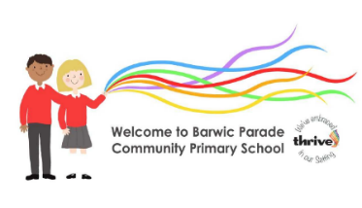
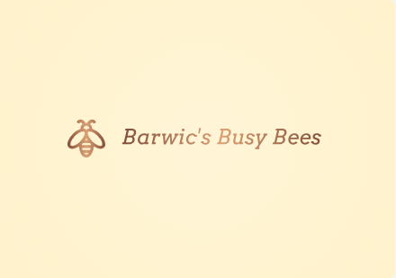
Barwic’s Busy Bees Rolling Curriculum-2 years 2024/25
Mr Snowdon
 | Aut 1 | Aut 2 | Spr 1 | Spr 2 | Sum 1 | Sum 2
Topics | ‘Magical Me’  People who help us | Amazing Animals  Seasons-Autumn/winter | Our senses/gross motor  Seasons-Spring  Food, glorious food! | Transport-things that go  Wonderful wildlife | Our garden  Growing things  Seasons-Summer | Beside the Seaside  Under the Sea
Key questions and vocab examples | Who am I  Who do I love?  Who do I live with?  Who helps me? | Animals-growth/growing, size, | What can I see/smell/hear and see? smell, scent, fell, touch, look, see, sound, hear | Fat, slow, speed, engine police car-police station, ambulance-hospital, tractor-farm | How we look after our plants?  Life cycle  Water, soil, sunshine, dig, planting | Ocean, sink, float, heavy, light, deep, shallow
Provision/activity enrichment | All about me home sheets | Bonfire night  Halloween  Christmas | Chinese/Lunar new year | Easter  World Book Day  Mother’s Day  Pancake Day | World Earth day | Father’s Day
Children’s individual interests to be empowered and extended throughout each term
Core texts examples | 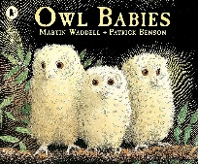  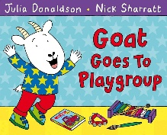 | 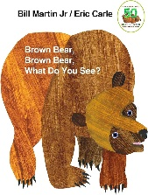  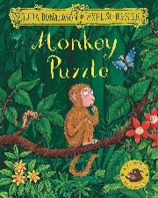  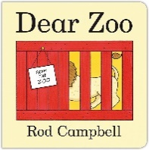 | 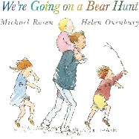  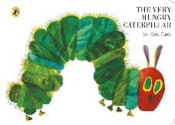  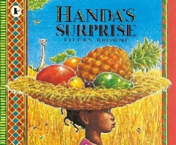 | 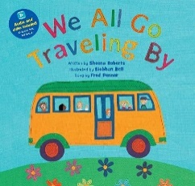  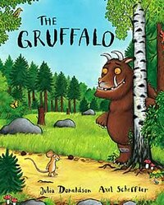 | 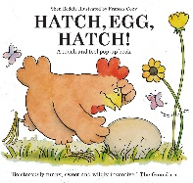  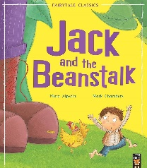  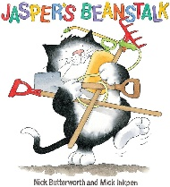 | 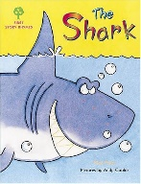  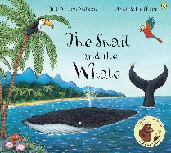  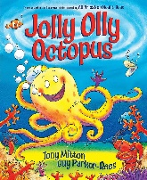
Nursery Rhymes  examples | Old McDonald had a farm, Wheels on the bus, Incy-Wincey spider, Twinkle twinkle little star, Baa baa black sheep etc.

Areas of Learning and Development | Autumn | Spring | Summer
Personal, Social and Emotional Development | - To build key person relationships, supporting children when separating from a Parent/Carer through the transitional period.  - With the support of a key person show an interest in play.  - Notice others around them.  - Build interactions through the interests of the child.  - To react to stimulus to help calm emotions and feelings for example: looking at family photographs together. | - To begin to find their own unique way of managing transitions.  - Begin to show confidence within their play.  - Play alongside their peers and developing friendships.  - With the support of an adult wait and take a turn for example rolling a ball or a car.  - Begin to show an awareness of themselves. Using various props and resources. | - To have developed a sense of assurance for example developing relationships with other adults and peers.  - Show independence within their play and making choices.  - To have established friendships with peers.  - To begin to demonstrate taking a turn independently.  - Explore emotions and feelings through stories and their play.
Communication and Language | - To begin to join in with some songs and Nursery Rhymes (even just with actions)  - To being to change attention to follow a prop or prompt.  - Listen to short stories in a small group.  - Use some single words to express their wants, needs and feelings.  - Recognise familiar objects to develop their vocabulary.  - Understand frequently used words, such as, ‘all gone’, ‘no’, ‘bye bye’. | - Recognise familiar environmental sounds and say what they can hear.  - Listen to some longer stories and join in with some key words and phrases in familiar stories.  - Build on their repertoire of Nursery Rhymes and begin to sing them unprompted.  - Begin to put a few words together and speak in simple sentences to express their wants, needs and feelings.  - Use the speech sounds p,b,m,w | - To be able to shift to a different task if attention fully obtained.  - Listen and follow one step instructions.  - Listen and join in during circle times, taking a more active role in participating.  - Know and sing a wide variety of Nursery Rhymes and songs.  - Role play familiar scenarios, communicating with one another, for example, going to the shops or the Doctors.  - Express themselves using a wide range of vocabulary and speak in longer sentences.
Physical Development | - Feeling secure and comfortable during nappy time.  - At snack time sitting together with peers.  - Sitting and walking independently. Begin to sit on a small bike and know how it is used.  - Showing an interest in exploring materials and tools. | - Showing an interest in Potty training.  - Sitting together for snack times and trying different tastes and textures.  - To gain control over their bodies through both indoor and outdoor play.  - Developing fine manipulative skills through using different objects and tools. | - To be independent with their self-help skills such as washing their own hands, using the toilet and attempting to fasten their own coat.  - Following snack time routines, making choices independently.  - To use large equipment, ride bikes and scooters with support.  - To be able to hold tools and objects using a palmer grasp comfortably.
Literacy-Reading | - To explore looking at books independently.  - Explore sensory books and learn new vocabulary related to their senses.  - Enjoy looking at class made books related to families.  - To look at some non-fiction books related to Topics in small groups e.g. Autumn, Christmas etc.  - To use a basic picture book and find information following a prompt. E.g. Where is the dog? | - To choose books that interest them independently and begin to understand how to handle them carefully, turning the pages independently.  - To obtain information from a more detailed image in a book following a prompt. E.g. What is the duck doing?  - Recognise their name alongside their photograph. | - Have a selection of favourite stories.  - To understand that stories have a beginning and the end and join in saying ‘The end’.  - To join in with key phrases when reading familiar books with adults.  - To talk in simple sentences and phrases about books the enjoy, using the images to help them.  - To listen to audio stories without images.  - Recognise familiar logos related to their interests.
Literacy-Writing | - To join in with short dough gym sessions to develop fine motor control  - To make marks on table tops to support core strength.  - Show an interest in mark marking- fingers, large apparatus, tools.  - Hold a tool with a fist palmer grip. | - Distinguishes between the different marks they make.  - Use tweezers to pick up a small object.  - To develop hand-eye co-ordination through scooping/pouring and filling activities. | - Imitate during simple shapes such as circles and lines.  - Make marks on a picture to stand for their name.  - Enjoy drawing freely using a range of tools.  - Notice some print such as familiar logo.  - Children to use a digital pronate grip.  - Use lacing cards to develop fine motor skills.
Maths | - To combine objects such as stacking blocks and cups.  - Put objects inside others and take them out again.  - Begin to take part in finger rhymes with numbers.  - To explore and use shape sorters and puzzles. | - To begin to compare sizes, bigger, little and smaller.  - To use number language in their play, beginning to sequence numbers orally 0-5.  - To complete an inset puzzle and to demonstrate matching and sorting skills within their play.  - To notice and comment on patterns including stripes and spots etc. | - To begin to use the language of weight in everyday contexts and through stories and rhymes.  - To explore space within the indoor and outdoor environment using their bodies to climb and travel through, over and under equipment to gain spatial awareness.  - To use objects to make simple arrangements, using associated language ‘the same’.  - Begin to count objects and actions in everyday contexts and counting up to 3 fingers.  - Begin to notice numerals in the environment and make comments on what they see e.g. numerals on doors, buses, clocks etc.
Understanding the word (Investigation & Exploration | - Play and explore in their natural environment displaying high levels of engagement.  - Children to begin to respond by simple comments and nonverbal gestures and movements.  - Begin to explore seasonal change e.g. the leaves are falling off the tree.  - Exploring senses –and purpose of body parts  - Naming body parts Exploring light and colours through sensory play. Exploring sound linking to bonfire night.  - Play with a variety of wheeled toys, exploring pushing and pulling. | - Continue to learn new vocabulary linking to seasonal change and notice the changes in the seasons.  - Observing changes of state through ice/water and using their senses to explore.  - Explore the natural world, focusing on digging and planting seeds.  - Observe and notice flowers and plants growing using their senses. | - Use descriptive terms, such as ‘hot’ and ‘cold’.  - Create simple dens with adult support and begin to understand shade and keeping cool.  - Use senses to explore sand/pebbles/water/bubbles.
UW-People, Cultures and Communities | - Recognise their family and key people during key person time.  - Children to name their family by using a family photograph.  - Understanding that Christmas is a special celebration.  - Settling in to their new environment and understanding where things are located in the classroom. | - Begin to imitate their own family and cultures through pretend play.  - Understanding that Easter is a special celebration.  - Begin to understand that there are different environments, for example, understanding that penguins live where it is cold. | - Bring in photos from family days out to share during Key Person time.  - Begin to have their own friends. Recognising familiar places and logos through looking at photos (local shops, places of interest).  - Talk about places they might go on a sunny day, for example, the beach.  - Imitate these experiences in the role play.
Expressive Arts and Design | - Explore different materials using all their senses.  - Begin to show an interest in early mark making.  - Explore sounds using musical instruments and sound makers.  - Use our voices to make sounds.  - Starting to develop imaginative play by exploring resources within the provision. | - Manipulate and play with different materials, exploring textures.  - Make early marks using various tools and equipment.  - Beginning to experience tone, pitch and volume.  - Join in singing songs and rhymes copying actions.  - Beginning to use resources imaginatively, using resources in different ways e.g. using a block as a phone. | - Use their imagination to begin to combine materials to make simple models, using tools to achieve what they have set out to do.  - Intentionally making marks in different styles.  - Expressing their ideas when mark making and sometimes giving meaning to them.  - Explore different rhythms, beat and using their bodies appropriately.  - Developing imaginative play from their own learning experiences, stories and rhymes.

