Nursery News!
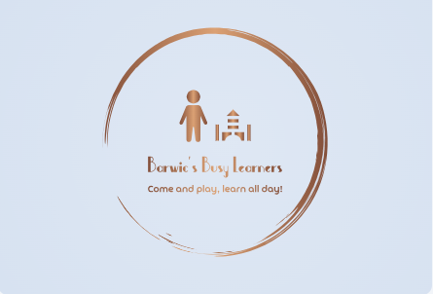
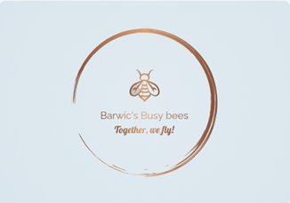

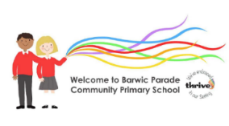

Autumn
Mr Snowdon Miss Birdsall
Wow Moments!
We love hearing about any special moments at home. Tell us all about them so that we can celebrate together at Nursery.
Our Nursery Family
We are so incredibly proud of how well the children have settled in to their first term after the summer holidays. We have welcomed lots of new children to Nursery and will continue to do so as we have new friends starting in the near future. Thank you to all our parents who have co-operated with us during your child’s transition to Nursery. We know how hard it can be leaving your child in a setting, away from you, however all children have coped so well and are thriving. They are an absolute credit to you.
Please have a read through the information below, where we keep you up to date with exciting Nursery news, our fun learning, top tips and guidance.

Toilet training
It is a positive step to start potty/toilet training between the ages of 18 months-2 years. This ensures that the children are as confident and comfortable as possible when using the toilet in Nursery. We are always on hand to support this process and look forward to working with you during this important time in your child’s development. During the process of toilet training, we ask all parents/carers to pack plenty of spare underwear and pull ups. We politely ask that children wear pull-ups, not nappies. Pull-ups are very similar to underwear, meaning that the children can learn to take them on and off, increasing their independence. For further information on toilet training please refer to the NHS website.

Dummies
We understand that dummies can be of great comfort to our youngest children but as they grow older, dummies can begin to have significant, negative impacts on speech and language. As a setting, we follow NHS guidance to support health and well-being. It is strongly advised that children be weaned off from dummies as young as possible. Children over 18 months should not be using a dummy at all. Because we are a setting that caters for ages 2-4 years, we cannot have dummies on site. We appreciate that dummy weaning can be challenging but we cannot stress enough how important it is for this to be done as soon as possible and when your child is as young as possible. The younger the child when weaned off a dummy, the greater their speech and language will be.






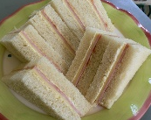




Nursery Lunches
We can provide your children with a hot lunch daily for £2.75, however you are more than welcome to provide your child with a packed lunch. NHS Healthier Families has some great, cost effective ideas for providing your child with a healthy and delicious pack up.



Any questions, as always we are happy to help.
Mr Snowdon and Miss Birdsall
A healthy wrap or sandwich
A piece of fruit/mixture of different fruits
Carrot/cucumber sticks
Pasta
A tasty yoghurt

