Reception Class- Summer 2 Newsletter
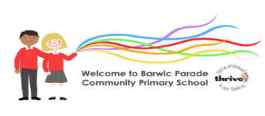


Welcome to Summer 1! Can you believe we are in our final term of this year already!

This half term, we will be embracing our natural world and the outdoors fully, starting with World Earth Day on 22.4.23 and Outdoor Classroom Day on Tuesday 25th April. Our focus for the first half of the summer is GROWING. We will be exploring the changes in the summer season and comparing England with our next Globetrotters adventure to Poland. As we have families in our community who are originally from Poland, we would love you to share any photos, traditions etc with us. We are all excited to be celebrating our new King Charles’ Coronation and we will be finding about more on our Royal family.
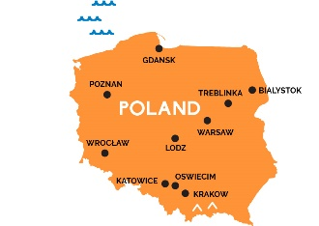

Our School Rules:
Ready , Respectful and Safe
Our Zone Board:
Gold: really impressing us
Silver: following all the rules
Blue: to remind us about a rule
Purple: making a deliberate wrong choice
We will continue to update you on Facebook and through Marvellous Me. Any questions, as always we are happy to help. Team Reception

What’s happening this half term?
- Outdoor Classroom Day 25.4.23
- Bank Holiday 1.5.23 school closed
- Coronation Day Special Lunch and dress in red, white and blue 5.5.23
- Bank Holiday 8.5.23 Coronation Day
- Special off menu lunch 18.5.23
- W/C 22.5 we will be globetrotting to Poland! If any Polish families would like to bring things in to show us, please see Mrs Ayed!
- Friday 26th May break up for May half term.
- School reopens on 5.6.23

Writing focus:
We are encouraging small, neat letters and chilDren checking their own writing. Finger spaces and full stops are really important too!

POLITE REMINDER TO BRING A WATERPROOF COAT, BOOKBAGS
AND WATER BOTTLE EVERY DAY!

