Reception Class- Spring 1 Newsletter
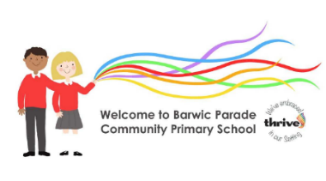


Welcome to Spring 2! This half term, we will be celebrating Shrove Tuesday (Pancake Day); holding our Phonics/Reading Workshop for parents and updating you on your child’s progress so far at Parents’ Evening. We will also be participating in World Book Day, where your children are invited to dress up characters from Wizard of Oz; thinking about Mothers’ Day and learning about the Christian celebration of Easter.

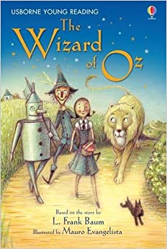

Reading
Reading certificates continue to be given for every 25 read at home. Please remember to sign in the planners!
Our children still need to be reading every day to use and apply what they have been learning at home for 5-10 minutes, as well as practising the new sounds and sight words.

Thank you for your ongoing support with this.

What’s happening this half term?
- Tue 21st February – Phonics/Reading Workshop 230pm
- Fri 24th February – Parents Thrive course – 9-11am
- Thurs 2nd March – World Book Day – dress up!
- Wed 8th March – Reception Reading Café 9am-930am and Parents Evening (appointments)
- Thurs 9th March Parents Evening
- Fri 31st March Reception Egg Hunt in the forest – parents invited.
Break up for Easter holidays!

This half term we are introducing News Books. These are for your child to take home and use to practice writing simple sentences on their own. You might want to use the phonics charts in their phonics packs to support this. Please let the children have a go at their own writing- you might want to scribe underneath after if you think we may need help reading these!
We would love to see the children having a go at writing a short sentence in the diaries too!
Our School Rules:
Ready , Respectful and Safe

Our Zone Board:
Gold: really impressing us
Silver: following all the rules
Blue: to remind us about a rule
Purple: making a deliberate wrong choice
We will continue to update you on Facebook and through Marvellous Me. Any questions, as always we are happy to help. Team Reception
This half term we will be learning:
- In Phonics Our next set of phase 3 phonics: ar, or, ur, ow, oi ear, air, ure and er.
- In Literacy we will be modelling and practising writing in sentences based on stories and non-fiction around Spring and Easter.
- In Maths we will be learning about continuing with mastery of numbers beyond 5

Pancake Day
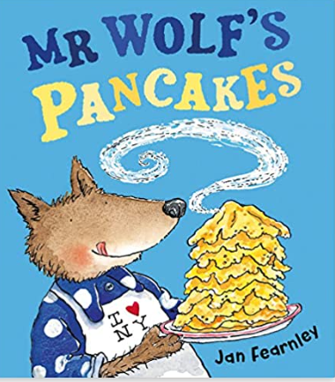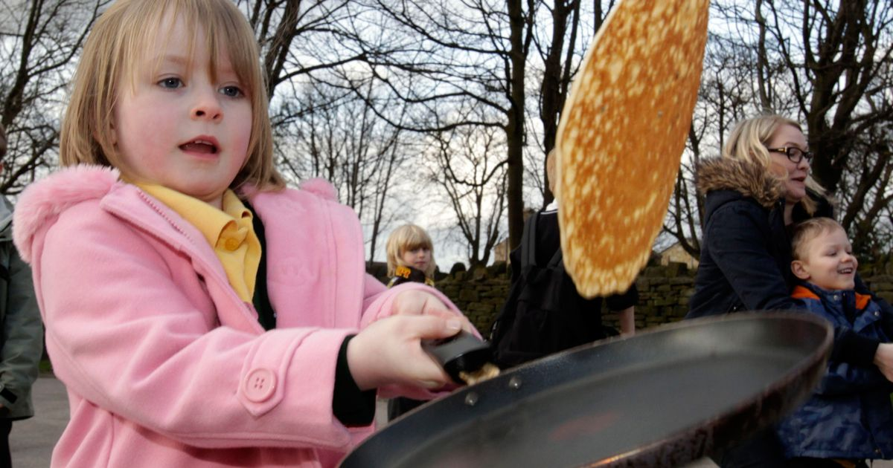

Mothers’ Day
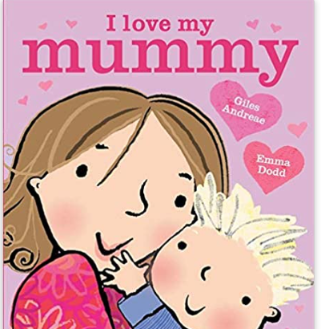
Easter
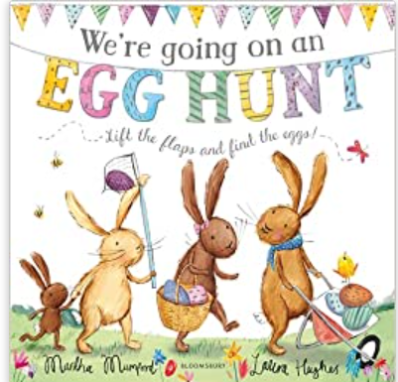

In Globetrotters Week will be learning all about Rwanda!

How you can help at home:
● Listen to your child read at home for 5-10 minutes every day, practising the sounds and sight words in the packs in the book bags. Don’t forget to record every time in the planner.
- Read a story as often as possible to your child!
● Practise writing letters, shopping lists, messages and short sentences at home. Use the News Books!
● Encourage greater independence eg getting dressed, walking to and from school, setting the table, tidying up, sweeping up, hoovering, dusting etc!
Children love to feel responsible and grown-up!

