Reception Class- Spring 1 Newsletter
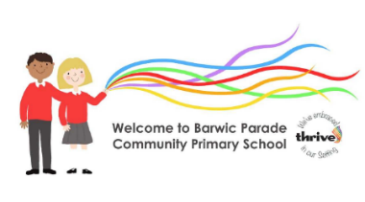
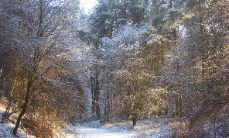

As the season of Winter sets in, we will be experiencing extremes of cold and wet weather. It is really important that we give our Early Years children the opportunity every day to embrace all weathers. In order to do this, we must make sure that they have the right clothing, including spare clothing and footwear aswell as waterproof coats with hoods. Please make sure that all belongings are named- coats, clothes, bottles etc.
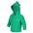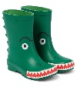
Outdoor learning – every day, twice daily
Tuesdays- Forest (old warm clothing and wellies)
Fridays – PE – kit or loose clothing

What’s happening this half term?
- 19th January – Special Lunch
- 6th February – Globetrotters Week
- 10th February – break up for half term
More info of any additional events will may be provided.
Reading
Reading certificates continue to be given for every 25 read at home. Please remember to sign in the planners!
Our children still need to be reading every day to use and apply what they have been learning at home for 5-10 minutes, as well as practising the new sounds and sight words.

Thank you for your ongoing support with this.

Thank you for your continued contributions to our diaries and photos of Barwic Bear when he gets to visit your homes! Our children love finding out about all of his adventures
We would love to see the children having a go at writing a short sentence in the diaries too! 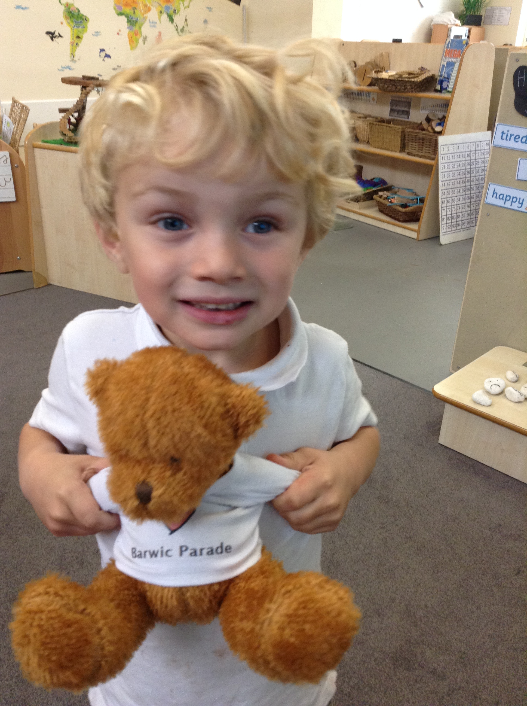
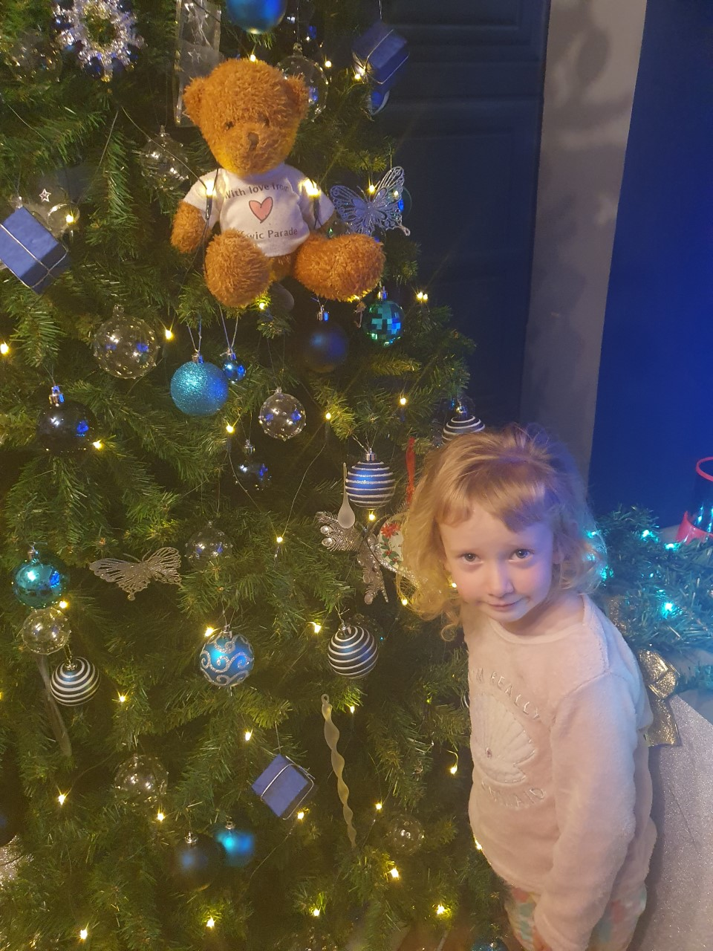
Our School Rules:
Ready , Respectful and Safe

Our Zone Board:
Gold: really impressing us
Silver: following all the rules
Blue: to remind us about a rule
Purple: making a deliberate wrong choice
We will continue to update you on Facebook and through Marvellous Me. Any questions, as always we are happy to help. Team Reception
This half term we will be learning:
- In Phonics Our next set of phase 3 phonics: j,v,w,x,y,z,zz,qu, ch, sh, th, ng, ai, ee, igh, oa and oo
- In Literacy we will be modelling and practising writing in sentences based on stories and non-fiction around Winter, including animals and their habitats including polar animals and hibernation.
- In Maths we will be learning about part/whole as well as continuing with mastery of numbers to 10 – subitising to 6 - recognising and naming numerals to 10 as well as composition of each of these numbers) –ordering, counting out loud and 1:1 correspondence and writing numerals correctly.
Culture Capital:
Chinese New Year/Lunar New Year


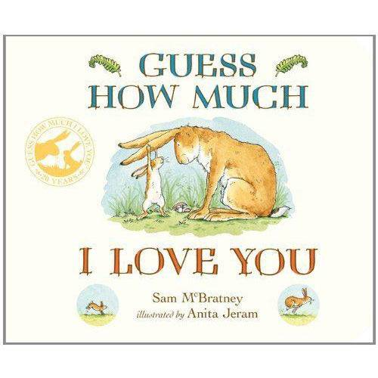
Globetrotters Week will be all about Rwanda!
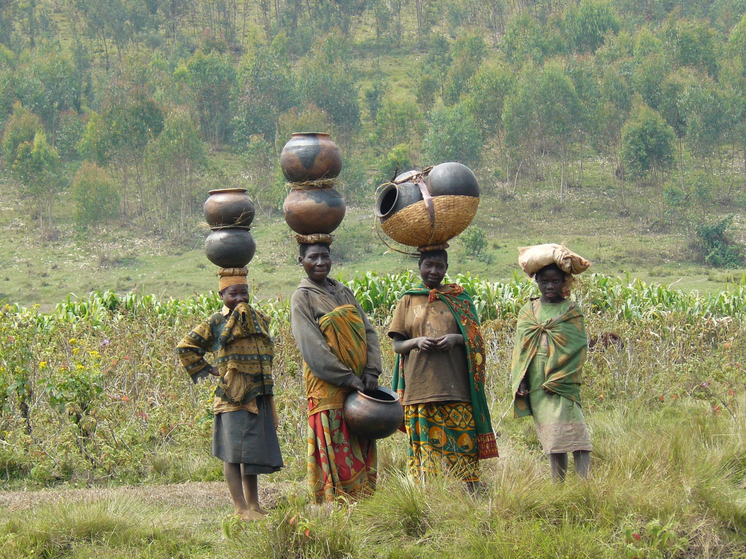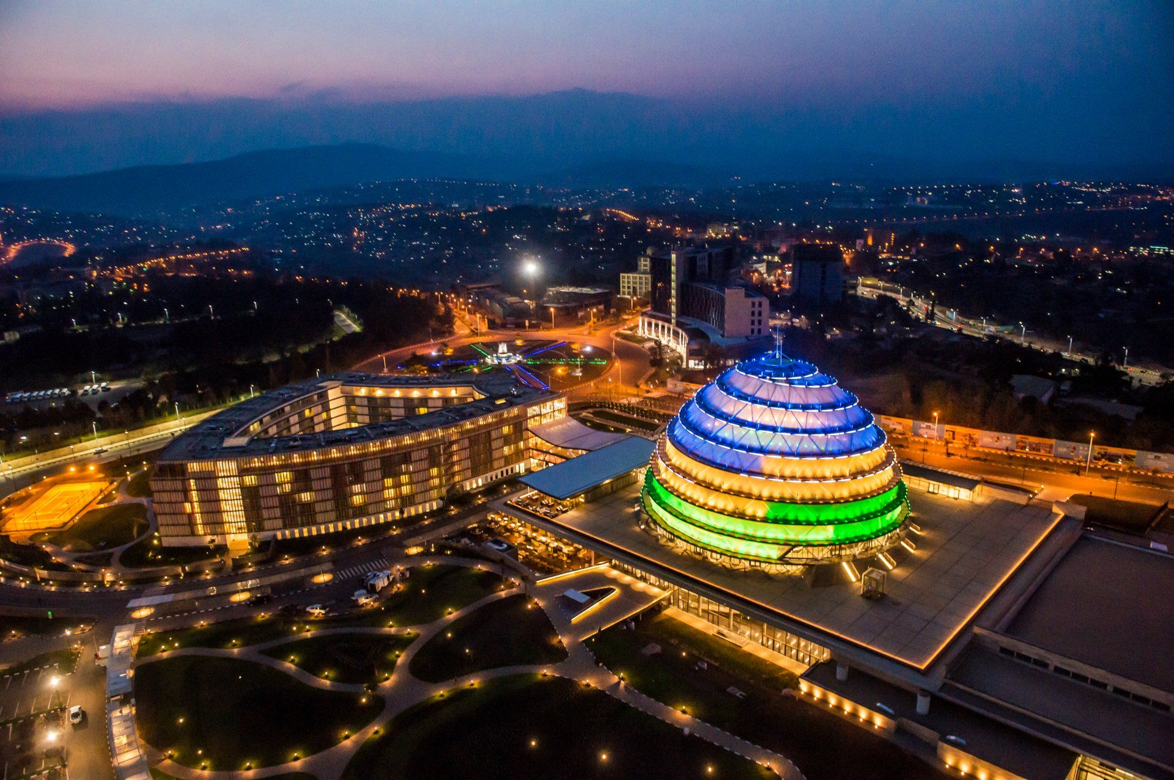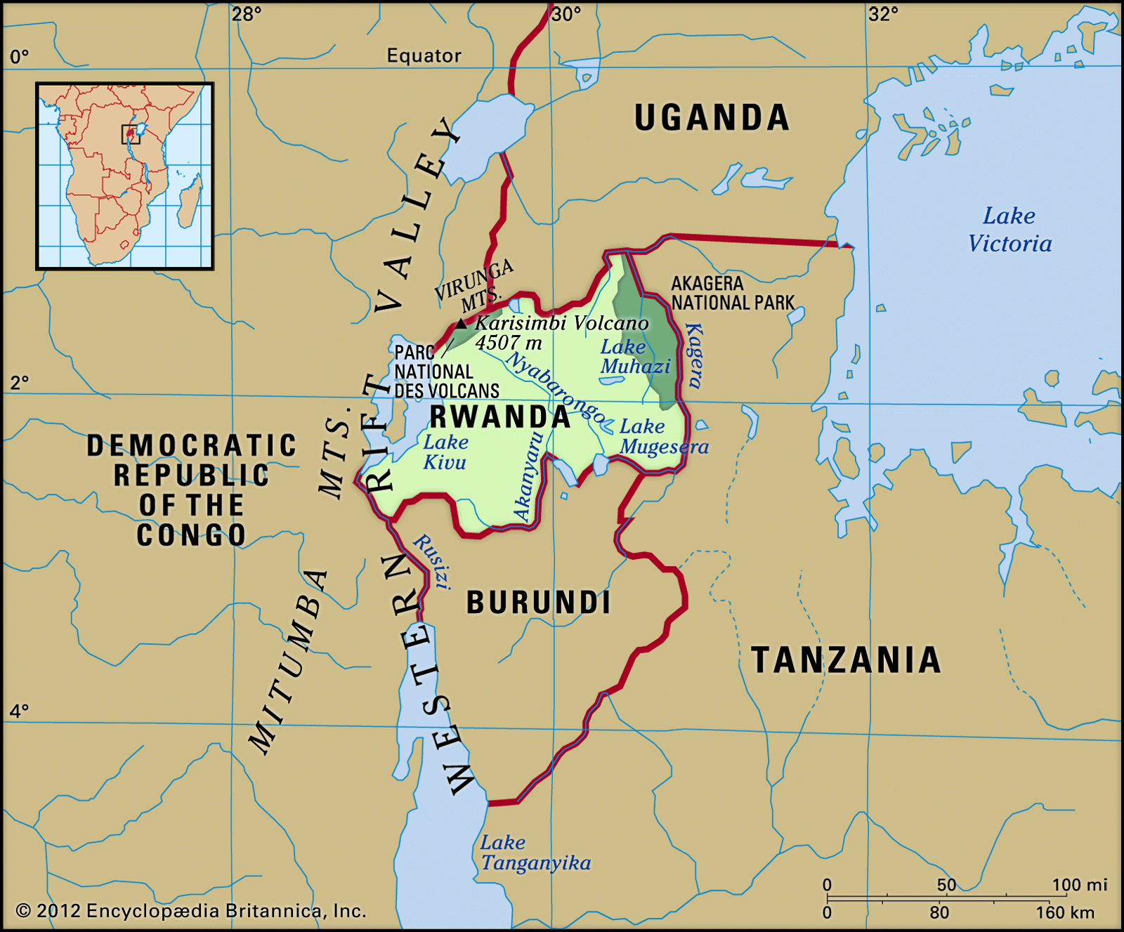
How you can help at home:
● Listen to your child read at home for 5-10 minutes every day, practising the sounds and sight words in the packs in the book bags. Don’t forget to record every time in the planner.
- Read a story as often as possible to your child!
● Practise writing letters, shopping lists, messages and short sentences at home.
● Encourage them to help out at home with jobs, eg making their beds, setting the table, hoovering, washing up, cleaning etc- they just love to help out and this helps with so many areas of learning, as well great teamwork!

