
Reception Class- Autumn 2 Newsletter

As the clocks go back and the nights seem to get earlier every day, we are ready for this excited for this special half term. It is going to be a busy one! Please make sure the children get a good night’s sleep on a school night – they should be having 12 hours at this age.

Dates for your diaries:
- ● Early Years open morning- 19th November
- ● Outdoor classroom day- 22nd November
- Trip to Lotherton Hall/Santa- 8th December 
- ●Christmas Fair- 9th December
- Nativity Performance – 14th December at 2pm 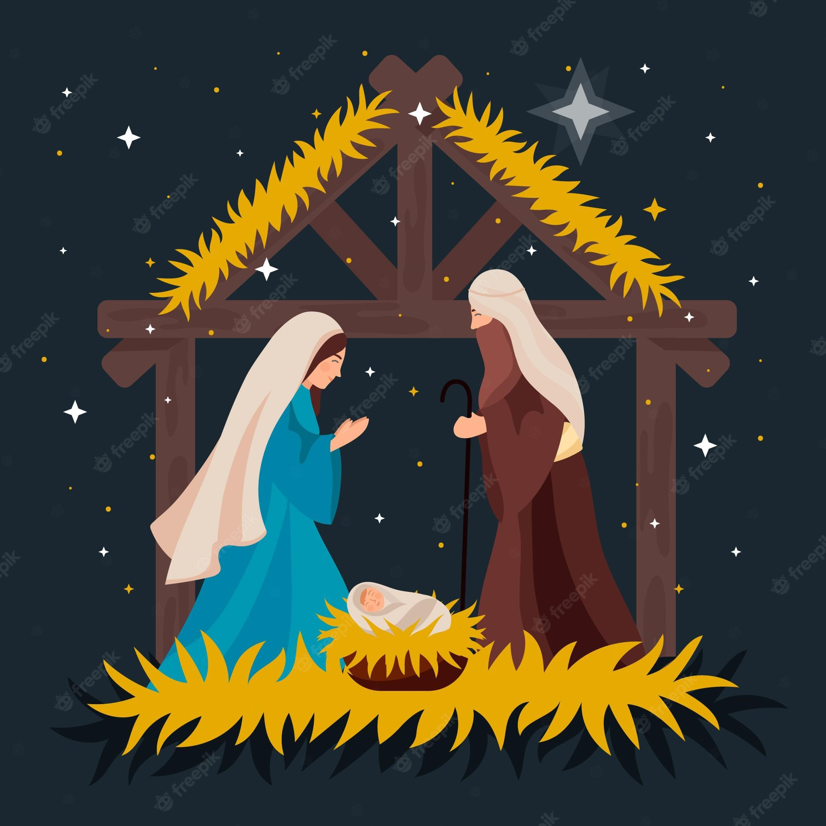
- Break up for Christmas – 16th December
More info will be provided soon
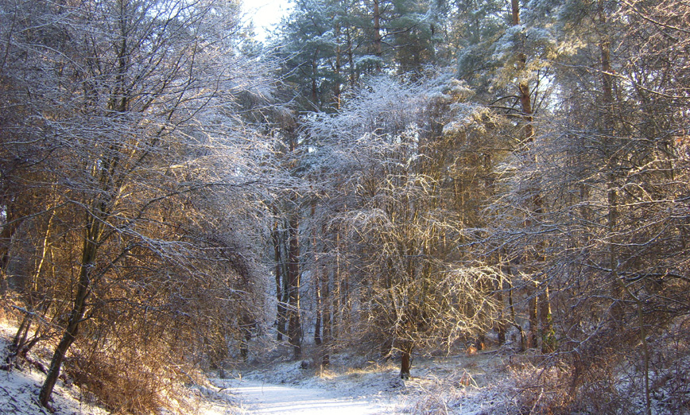 Our forest session is every Tuesday afternoon. 
Children need to come in warm old clothing, waterproof hooded jackets and wellies. We enjoy hot chocolate/milk after these sessions to warm up!
Please make sure that all belongings are named- coats, clothes, bottles etc.
Thank you
Our outdoor area has been rearranged for the winter. Although we appreciate it is tempting, please help us to keep these areas zoned and our resources ready for learning, by discouraging the children and their siblings from using them before and after school. As the weather changes, the children can get quite wet and/or dirty outside and need to have a spare set of named clothing and footwear in school at all times.
Thank you for the amazing diaries and photos of Barwic Bear! We love finding out about his adventures Who will he have a sleepover with next?

Reading Café 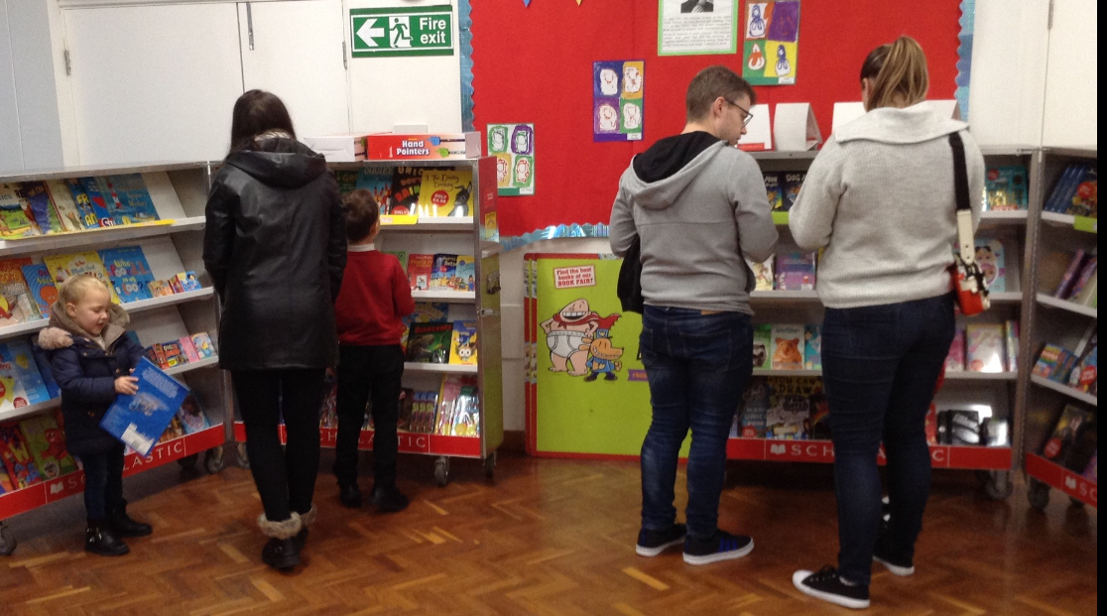
Thank you to everyone who came along. It was fantastic to see children enjoying reading with their families! You can still get discounted books from the Book Fair on Parents Evenings. It will be in the hall!
Don’t forget to read together at home every day to earn our reading certificates too!
We’ve loved getting to know your children last half-term, we had so many lovely moments. Any questions, as always we are happy to help.
Mrs Ayed, Mrs Ault, Miss Fawcett and Mrs Fawcett
Our Maths Journey so far…
- Subitising to 3 ( 4 and 5 next)
(Knowing quickly how many- eg on a dice/domino or a group of the same objects or spots_)
- Recognising and naming numerals 0,1,2,3 (4 and 5 next as well as composition of each of these numbers)
- Ordering numbers
- Counting out loud and 1:1 correspondence
- Writing numerals
How you can help at home:
● Listen to your child read at home for 5 minutes every day, practising the sounds and sight words in the packs in the book bags. Don’t forget to record every time in the planner.
● Practise writing letters and names at home.
● Encourage your child to look after their own belongings and putting things back where they belong at home.
- Children love to get hands on! Get them involved in laying the table, clearing up, washing and drying up. Or even cleaning the car together- the messier the better!

Our Reading Journey focus book studies so far…
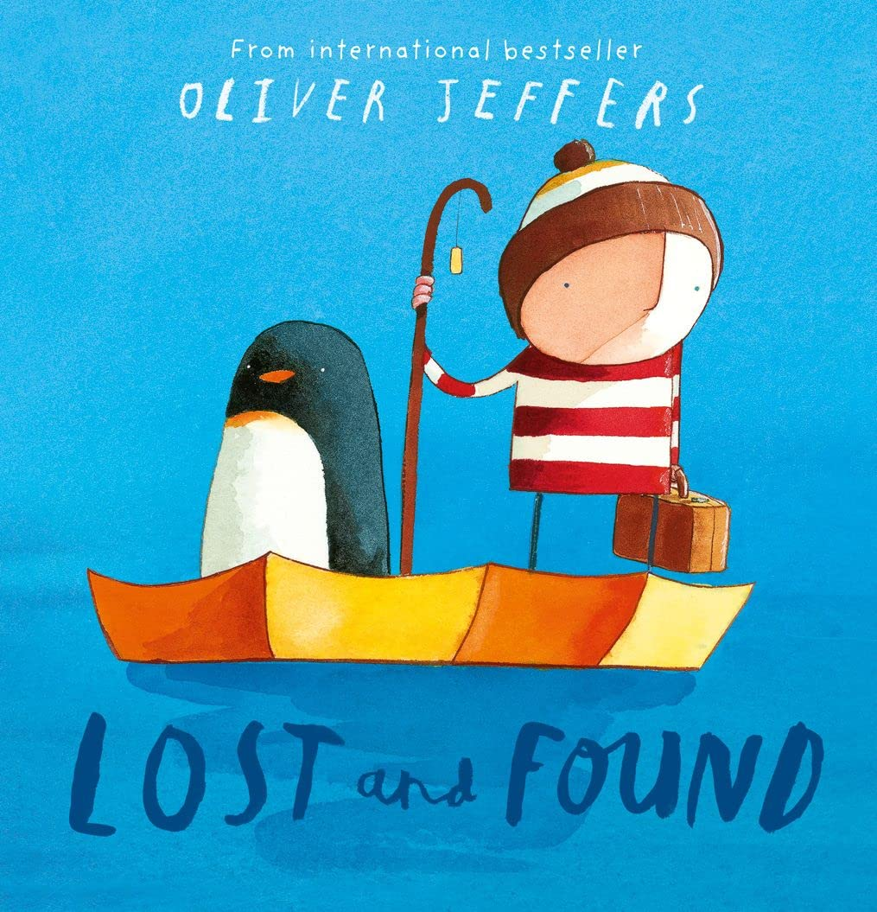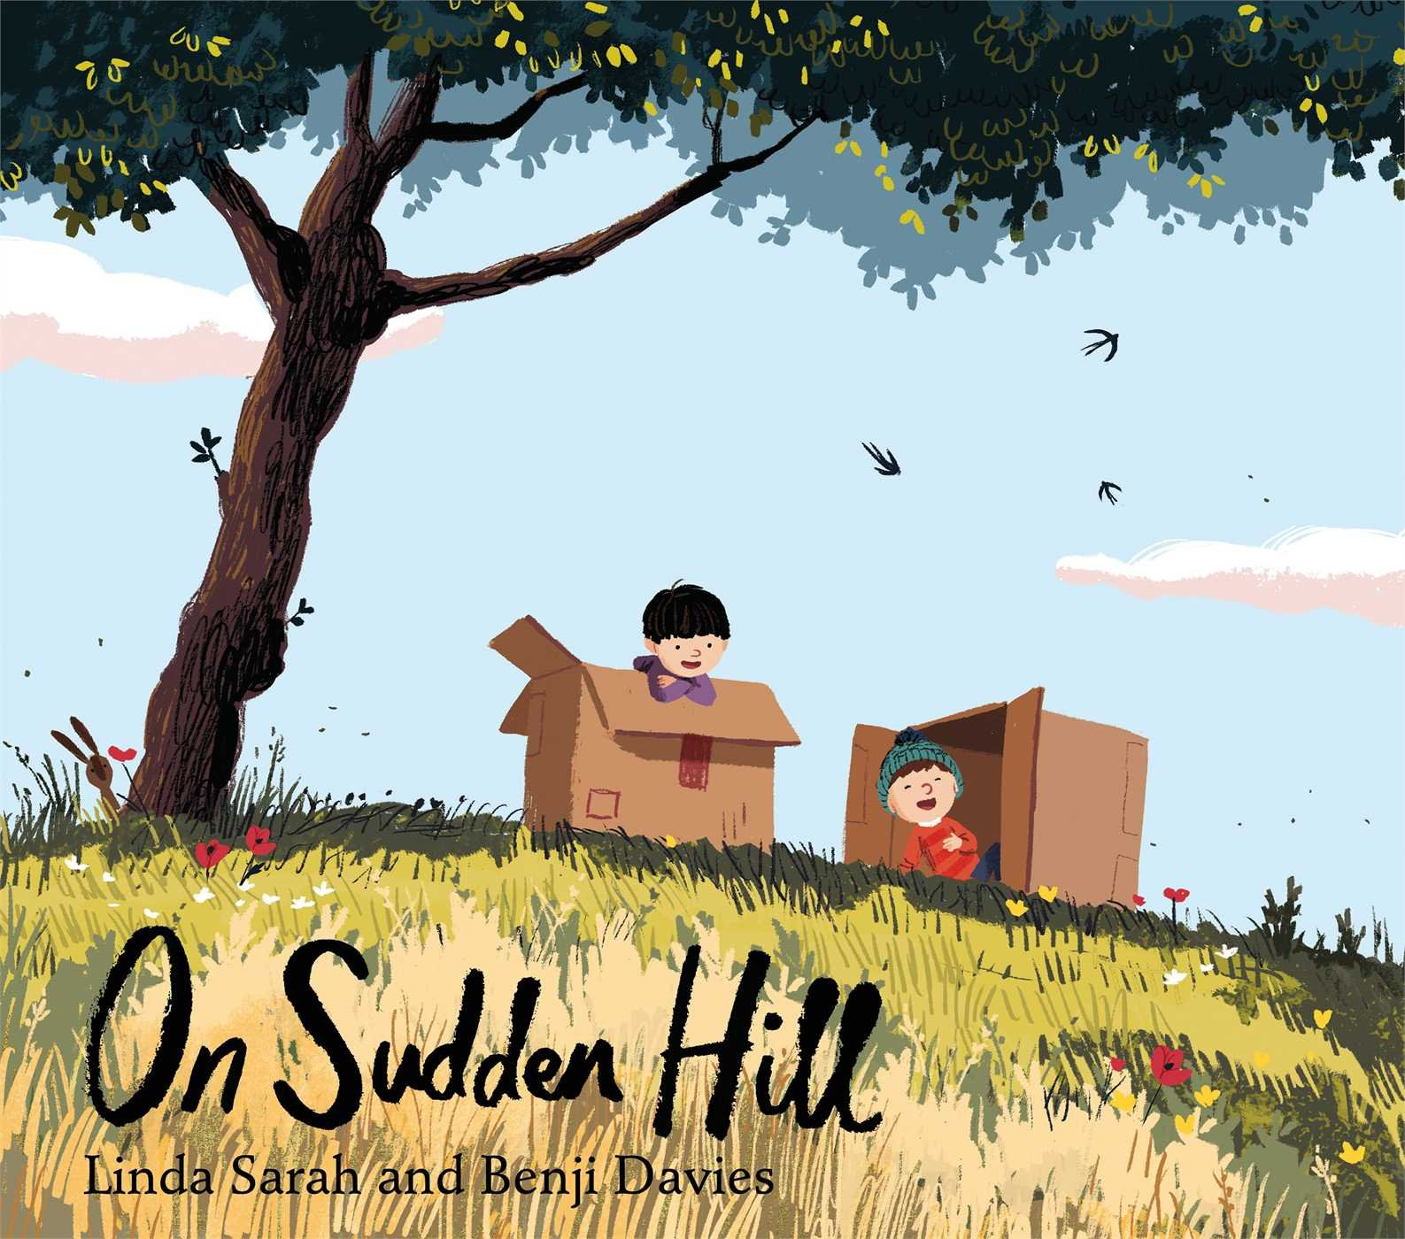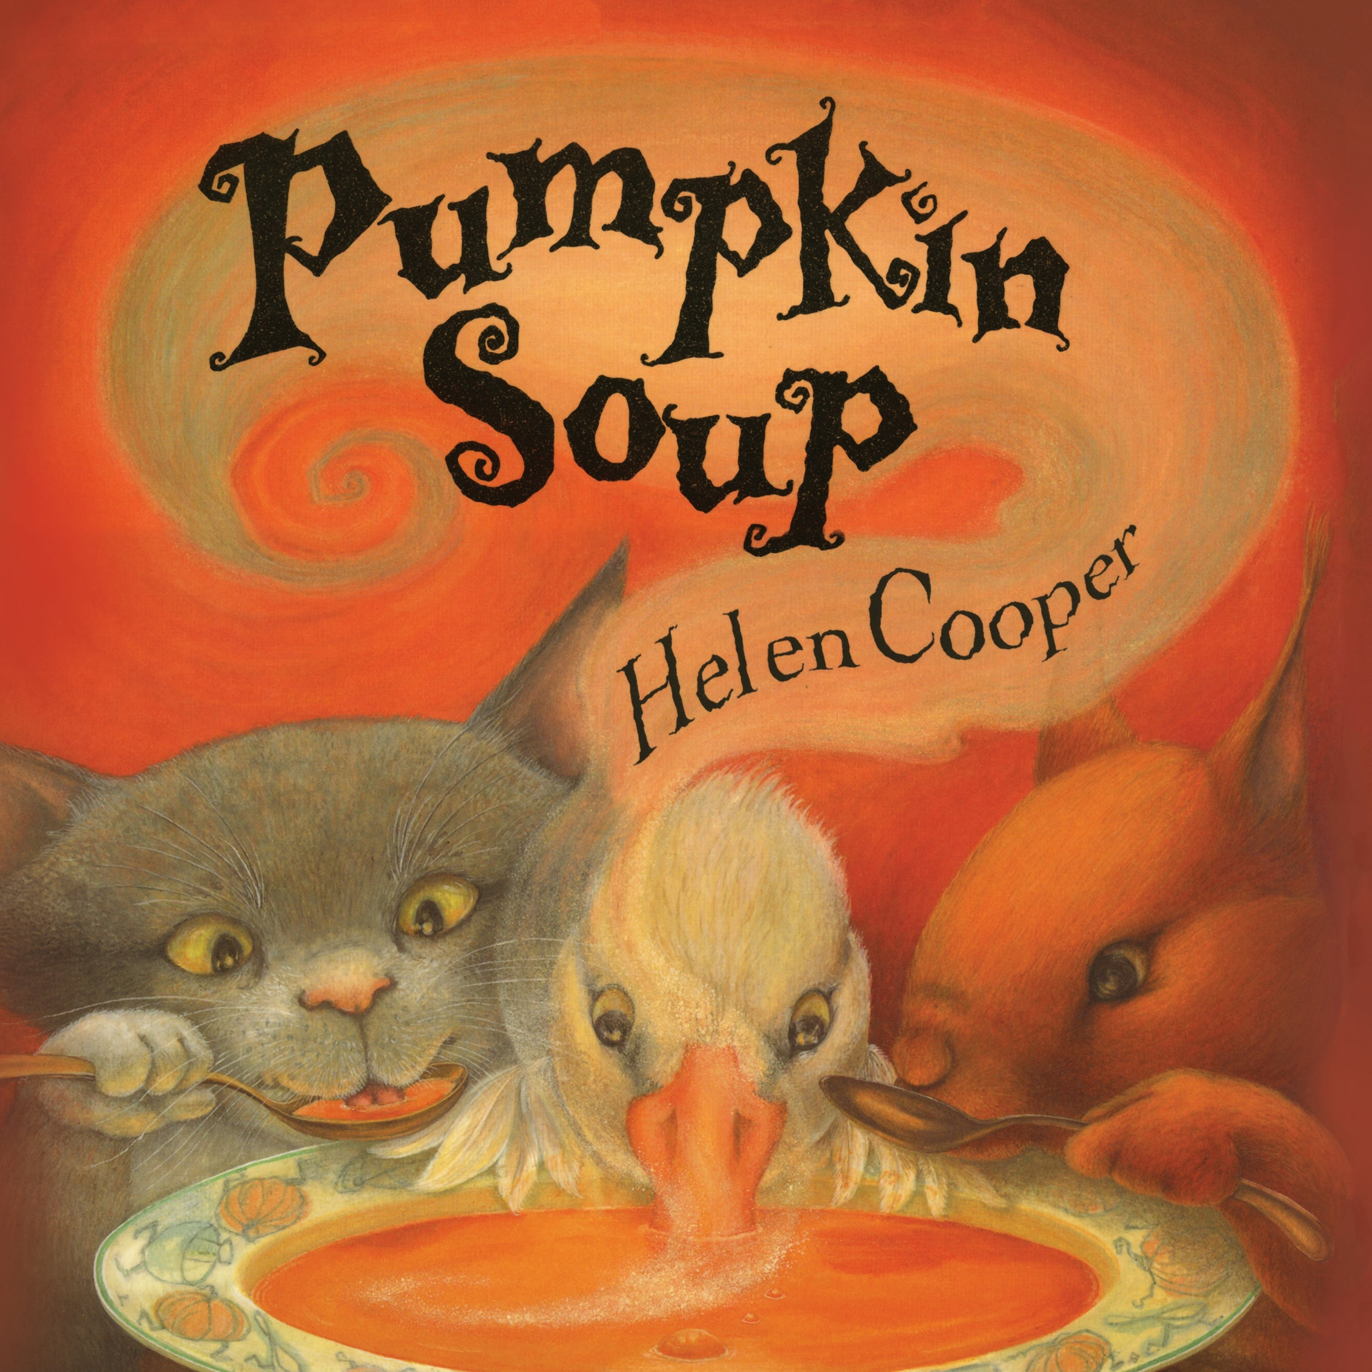
Our library is full of quality stories that our children love. They sign their own books in and out too!
Our writing journey so far…
- Writing our name independently
- Writing the letters we have learned
- Having a go at words and simple phrases

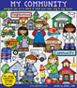
We will be learning:
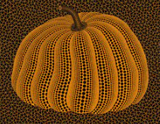
- Halloween/Pumpkin Soup story study
- Why we have Bonfire Night and Remembrance Sunday
- World Nursery Rhyme Week
- The Nativity Story
- Globetrotters- Mexico!


