Area of Learning | Autumn 1 | Autumn 2 |  | Spring 1 | Spring 2 | Summer 1 |  |  | Summer 2
T  Possible Themes/Interests/Lines of Enquiry     | ALL ABOUT ME (Reception Baseline Assessments)  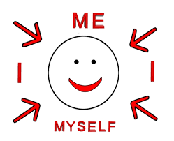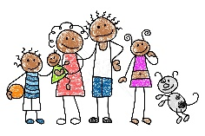  Settling in to school life/making friends/following routines/looking after my belongings/respecting resources and putting things back where they belong.  What do I look like? - Self-portaits.  Family – who are my family?  Feelings  Where do we live? Compare Selby with South Pole  (Barwic Bear home diary) Where have I been?  Dinosaur Week  Space Week  SEASONS: AUTUMN 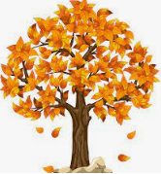– colours/weather/ seasonal changes - how many different ways can we use natural treasure such as sticks/leaves/conkers?  CELEBRATIONS:    (Diwali  Space Week – Our Planet Earth and beyond  RE: Diwali –Festival of Light- Which people are special and why? (Family/friends/school staff/doctors)  OUR FOREST: Our 5 senses What can we see up high/around us/on the ground and underneath things? Risky play  An introduction to our on-site forest and weekly afternoon sessions, including our trim trail; giant sandpit; mud kitchen; deb building giant tyres and log circle.  WHOLE SCHOOL GLOBETROTTERS: - France  Learning some greetings vocabulary/Listening to traditional music and dance/what do people east? Wear? Do? Famous traditions? Landmarks? | ALL ABOUT ME  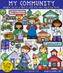  My journey to school- Local community- where do I live?  My home  Holidays? (Link to the world) Circus/zoo/farm-animals and their habitats/seaside/England.  People who help us- Medical profession/Police/Fire  Christmas around the world  Space- the sun and the moon  SEASONSAUTUMN colours/weather/changes- hibernation  CELEBRATIONS:  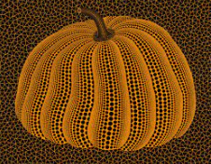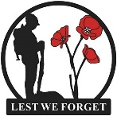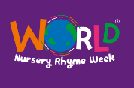  Halloween, Bonfire Night, Remembrance Day, Nursery Rhyme Week, Children In Need, Christmas Around The World  RE: The Nativity Which stories are special and why? Hannukah  Key RE vocab: God,Jesus, Nativity, Christians, Christianity, Bible, Church, religion  FOREST: “Stick Man “Not A Stick!” and “Stanley’s Stick”  GLOBETROTTERS:  Learning some greetings vocabulary/Listening to traditional music and dance/what do people east? Wear? Do? Famous traditions? Landmarks? |  | Extreme cold climates- ice and snow/habitats- The North and South Pole  Space – a trip to the moon  Materials - waterproof  SEASONS: WINTER  CELEBRATIONS: Valentine’s Day/ Who do we love?  Chinese New Year  *Number Day:  RE: Being special: where do we belong? (Link to Valentine’s Day – who do we love.  FOREST:  Forest out of action being updated  GLOBETROTTERS:  Learning some greetings vocabulary/Listening to traditional music and dance/what do people east? Wear? Do? Famous traditions? Landmarks? | WELLBEING/HEALTH/Senses/ Healthy Eating/Hygiene/Oral Hygiene  /Being Active/ Living Things: Growing - Growing up – babies - generations planting/gardening  Living Eggs- Lifecycle of a chick  SEASONS: SPRING  CELEBRATIONS: Easter, Mother’s Day, Pancake Day  *World Book Day*  RE: What places are special and why?/The Easter Story  RE: key vocabulary: Easter, Jesus, Church, Christians, Christianity, Bible  FOREST: “The Tree”  GLOBETROTTERS:  Learning some greetings vocabulary/Listening to traditional music and dance/what do people east? Wear? Do? Famous traditions? Landmarks? | Lifecycles –tadpoles/growing up – generations  Local Community  EID  World Earth Day  Growing: Planting Mr Grassheads  SEASONS: SUMMER – colours/weather/changes  CELEBRATIONS: VE Day 8th May  RE: What is special about our world?  RE: Key vocabulary: Muslim, Allah, Qu’ran, Mohammed, religion, Mosque  FOREST: “The Earth Book”  Frogs/plant/sunflowers  Local Area – where have we been? Mapping  GLOBETROTTERS:  Learning some greetings vocabulary/Listening to traditional music and dance/what do people east? Wear? Do? Famous traditions? Landmarks? |  |  | Growing: Planting sunflowers  Hot climates (Australisa) /habitats  Seaside past and present  Summer  Celebrate yourself/Sports Day/Graduation  SEASONS: SUMMER  CELEBRATIONS: Queen’s Platinum Jubilee Graduation  Past and present – old and young, then and now  Outdoor Learning Day  FOREST: Using our senses  Parent open workshop  RE: What times are special and why?  Moving on  GLOBETROTTERS:  Learning some greetings vocabulary/Listening to traditional music and dance/what do people east? Wear? Do? Famous traditions? Landmarks?
Communication and Language  Listening 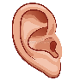  Speaking 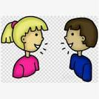  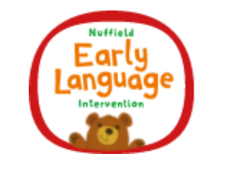 | Carpet time rule: listening (looking at the front) and why whole body listening is always important for our learning /Engage in story times, rhymes and songs./Maintain attention in whole class/groups. /Follow 1 step instructions. /Understand ‘why’ questions. /Use sentences 4-6 words. /Use talk to organise play- practitioner uses shared sustained thinking in play  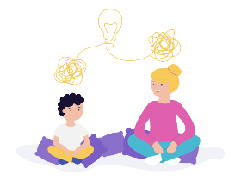 | Follow instructions with 2 parts in a familiar situation. Start a conversation with peers and familiar adults and continue for many turns. Develop social phrases |  | Listen attentively in a range of situations. Maintain attention during appropriate activity. Engage in non-fiction books. Consider the listener and take turns. Use talk to organise/stand for something else in play. Begin to use past tense. Begin to recount past events. | Understand why listening is important. Maintain attention in different contexts. Use talk to help work out problems and organise thinking and activities explain how things work and why they might happen. Ask questions to find out more and check understanding. Articulate their ideas and thoughts in well-formed sentences. Listen to and talk about selected non-fiction to develop a deep familiarity with new knowledge and vocabulary Begin to connect one idea or action to another using a range of connectives. Describe events in some detail. | Listen and understand instructions while busy with another task. Maintain activity while listening. Understand how, why, where questions. Describe events in some detail. Express ideas about feelings and experiences. Articulate their ideas and thoughts in well-formed sentences. Use language to reason. |  |  | Listen and respond with relevant questions, comments, or actions. Attend to others in play. Make comments and clarify thinking with questions. Retell the story once they have developed a deep familiarity with the text; some as exact repetition and some in their own words. Speak in well-formed sentences with some detail. Use new vocabulary in different contexts. Use past, present, and future tenses in conversation with peers and adults. Use conjunctions to extend and articulate their ideas. .
 | Learn new vocabulary Listen carefully to rhymes and songs, paying attention to how they sound. Use new vocabulary in different contextsnew vocabulary through the day Learn rhymes, poems, and songs.
Personal, Social and Emotional Development  Self-regulation  (Whole school rules: READY/RESPECTFUL AND SAFE)  Managing Self  Building Relationships  | Baby Bear friendship activities 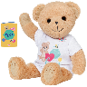  – Somewhere New/ Making Friends/Sharing Is Caring How I Feel/Dressing Up  Ready – what does being ready look like?  BEING ME IN MY WORLD: self-esteem. (I am special) Know my likes and dislikes.  Make friends, share and take turns with support. Build constructive and respectful relationships. Begin to follow school rules. (with support as appropriate)  Look after own belongings, manage own basic hygiene and personal needs including dressing and going to the toilet.  Begin to be confident to try new activities, show independence, resilience and perseverance in the face of challenge- able to negotiate in play. |  | Respectful - What does being respectful look like?  CELEBRATING DIFFERENCE (INCLUDING BULLYING)  Begin to express their feelings and consider the perspectives of others. Begin to take turns and share resources. Independently choose where they would like to play. Continue to build constructive and respectful relationships | Circle Time/Stories/Zoneboard- READY/RESPECTFUL AND SAFE  SAFE- What does safe look like for ourselves and our things ?  DREAMS AND GOALS  Show pride in achievements. Understand behavioural expectations of the setting. Can explain right from wrong and try to behave accordingly. Manage their own needs. Can identify kindness. Seek others to share activities and experiences. | Circle Time/Stories/Zoneboard- READY/RESPECTFUL AND SAFE  READY: Name things we need to be dong to be ready to listen and learn: Sitting in our places/legs crossed/lips closed/listening ears/thinking brains  HEALTHY ME  Understanding the importance of healthy food choices.  Can make choices and communicate what they need. Begin to show persistence when faced with challenges. Can keep play going by co-operating, listening, speaking, and explaining. Can reflect on the work of others and self-evaluate their own work. | Circle Time/Stories/Zoneboard – READY/RESPECTFUL AND SAFE  –RESPECTFUL  Respectful – How do we show respect for each other and our  things/environment?  RELATIONSHIPS  Beginning to know that children think and respond in different ways to them. Can talk about their own abilities positively. Confident to try new activities. Show resilience and perseverance. | Circle Time/Stories/Zoneboard – READY/RESPECTFUL AND SAFE  -SAFE- How do we stay safe? How do we keep each other safe? What isn’t safe?  CHANGING ME  Able to identify and moderate own feelings. See themselves as a unique and valued individual. Can seek out a challenge and enjoy the process. Show sensitivity to others’ needs and feelings.
 | NB. These statements have been split for extra focus, but all will apply on an ongoing basis throughout the reception year.
Physical Development  PRO PE 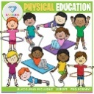  Gross Motor Skills  Squiggle Floor Large Scale/Outdoor/Trim trail/Forest  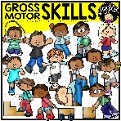  Fine Motor Skills (ART)  Dough disco/Squiggle small WBs/Continuous provision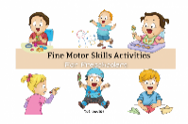 | Develop the skills they need to manage during the school day: lining up and queuing, mealtimes, personal hygiene, special awareness indoors and outdoors.  Hold a pencil effectively using tripod grip. Use a range of small tools, including scissors, paintbrushes and cutlery. | Revise and refine the fundamental movement skills they have already acquired: rolling, crawling, walking, jumping, running, hopping, skipping, climbing. Social Cog Focus – taking turns and sharing. Dynamic balance to Agility skill: Jumping and Landing Static Balance skill: Seated balance  Develop accuracy and care when drawing. (Squiggle While You Wiggle flapper dances/large scale floor movement drawing/Copying from screen/ Symbolic |  | Further develop and refine a range of ball skills including throwing, catching, kicking, passing, batting, and aiming. Develop confidence, competence, precision, and accuracy when engaging in activities that involve a ball.  Creative Cog Focus – Exploring and describing different movements Coordination skill: Ball skills Counterbalance skill: With a partner | Know and talk about the different factors that support their overall health and wellbeing: regular physical activity, healthy eating, toothbrushing, sensible amounts of ‘screen time’, having a good sleep routine, being a safe pedestrian.  Cognitive Cog Focus – understand and follow simple rules, name some things I am good at. Dynamic balance: On a line Static Balance skill: Stance | Combine different movements with ease and fluency Develop the foundations of a handwriting style.  Applying Physical Cog Focus – Performing a single skill or movement with some control, performing a range of skills and link two movements together. Coordination skill: Sending and Receiving Agility skill: Reaction/Response |  |  | Confidently and safely use a range of large and small apparatus indoors and outside, alone and in a group.  Health and Fitness Cog Focus – Aware of why exercise is important for good health. Agility skill: Ball chasing Static balance skill: Floor work
Develop the overall body strength, co-ordination, balance, and agility needed to engage successfully with future physical education sessions and other physical disciplines including dance, gymnastics, sport.
Develop using e a range of tools competently, safely, and confidently. Suggested tools: pencils for drawing and writing, paintbrushes, scissors, cutlery, chopsticks.
Use their core muscle strength to achieve a good posture when sitting at a table or sitting on the floor. Show accuracy and care with drawing and letter formation.

Literacy  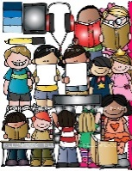  Jane Considine Fantastics Reception programme, including emotional literacy; Grandma Fantastic key vocabulary  Comprehension | Comprehension: Listen and enjoy sharing a range of books. Hold a book correctly, handle with care. Know that a book has a beginning and an end and can hold the book the right way up and turn some pages appropriately. Know that text in English is read top to bottom and left to right. Know the difference between text and illustrations. Recognise some familiar words in print, e.g., own name or advertising logos. Enjoy joining in with rhyme, songs and poems. Explain in simple terms what is happening in a picture in a familiar story. Complete a repeated refrain in a familiar rhyme, story or poem being read aloud.  KEY TEXT: Studies: Lost and Found and Pumpkin Soup  Over and Over: 10 texts repeated over 6 weeks  Story time texts: see classroom displays: The Gruffalo/Stick Man  Retell stories in own words, developing vocabulary. | FEATURE AUTHOR:  Comprehension: Experience and respond to different types of books, e.g., story books, factual/real-world books, rhyming and non-rhyming stories, realistic and fantasy stories. Respond to ‘who’, ‘where’ ‘what’ and ‘when’ questions linked to text and illustrations. Make simple inferences to answer yes/no questions about characters' emotions in a familiar picture book read aloud to them, with prompts. Sequence two events from a familiar story, using puppets, pictures from book or role-play.  KEY TEXTS:  Stick Man, The Nativity, Gruffalo’s Child and Threadbear.  Blend sounds into words made up of known letter-sound correspondences.  Anticipate key events in stories.  Read a few sight words matched to our phonic programme |  | FEATURE AUTHOR: Cressida Cowell/Julia Donaldson  Comprehension: Use picture clues to help read a simple text. Make a simple prediction based on the pictures or text of a straightforward story that is read aloud to them. Show understanding of some words and phrases in a story that is read aloud to them. Express a preference for a book, song or rhyme, from a limited selection. Play is influenced by experience of books (small world, role play).  Key Texts: Guess How Much I Love You Whatever Next, Fraser Bear, One Snowy Night, Snail and the Whale Lost and Found Snow Bears/Penguins, Polar Animals, | FEATURE AUTHOR:  Comprehension: Retell stories in the correct sequence, draw on language patterns of stories. With prompting, show understanding of many common words and phrases in a story that is read aloud to them. Suggest how an unfamiliar story read aloud to them might end. Give a simple opinion on a book they have read, when prompted. Recognise repetition of words or phrases in a short passage of text. Play influenced by experience of books Innovate a well-known story with support  .BOOKS OF THE WEEK: Owl Babies, The Wolf’s Pancakes, Titch, Jasper’s Beanstalk and The Tiny Seed | FEATURE AUTHOR: Enid Blyton  Comprehension: Correctly sequence a story or event using pictures and/or captions. Make simple, plausible suggestions about what will happen next in a book they are reading. Know the difference between different types of texts (fiction, nonfiction, poetry) Make inferences to answer a question beginning 'Why do you think…?' in a picture book that has been read to them, where answer is clearly signposted. Play influenced by experience of books - gestures and actions used to act out a story, event or rhyme from text or illustrations.  BOOKS OF THE WEEK; Superworm, The Hungry Caterpillar, Hatch Egg Hatch, Goz – When I Grow Up. Write lower case recognisable letters correctly.  Write simple phrases or sentences that can be read by others. Spell words by identifying the sounds and then writing the sound with letter/s. |  |  | FEATURE AUTHOR  Comprehension: Play influenced by experience of books - act out stories through role play activities, using simple props (e.g. hats, masks, clothes, etc.) and appropriate vocabulary. Innovate a known story. Recall the main points in text in the correct sequence, using own words and include new vocabulary. When prompted, say whether they liked or disliked a book, and give a simple justification or make a relevant comment. With prompting, sometimes show understanding of some less familiar words and phrases in a story that is read aloud to them  BOOK OF THE WEEK: Sharing a Shell, Snail and The Whale, Handas Surprise/Hen, You be You and I am Enough. Write short sentences with words with known letter-sound correspondences using a capital letter and full stop.  Re-read what they have written to check that it makes sense.
Word Reading:  Phonics  A Reading book from reading scheme to read at home each week that matches the sounds children know.  Library book – each week the children visit the school library and choose a book of their choice to red for pleasure at home with family.  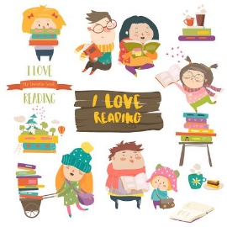  Writing  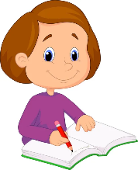 | WORD READING  Hear general sound discrimination (Phase 1) and be able to orally blend and segment simple words.  Read individual letters by saying the sounds for them. Phase 2 – s,a,t,p,i,n,m,d,g,o,c,k,ck, e,u,r and know sight words: I, the, to, go, no, into | Word Reading:  Read individual letters by saying the sounds for them. Blend sounds into words, so that they can read short words made up of known letter-sound correspondences.  Phase 3-  j,v,w,x,y,z,zz,qu  Phase 2 Know grapheme phoneme correspondence of 19 letters. Blend with known letters for reading VC and CVC words. Orally segment for VC and CVC words for spelling Know sight words (the, to, no, go).  Phase 2/3 Consolidate Phase 2 skills.  Begin Phase 3 skills – Know the remaining grapheme -phoneme correspondence for j, v, w, x, z, zz, qu |  | Word Reading: Read individual letters by saying the sounds for them. Blend sounds into words, so that they can read short words made up of known letter-sound correspondences. Read a few sight matched to our phonic programme  Phase 3  ch,sh,th,ng, ai,ee,igh,oa,oo/oo  Phase 2 Consolidate skills as in Autumn 2. Recognise digraphs -ck + consonant endings - ff, ll, ss Know sight words - the, to, and, no, go, I Blend and segment known sounds for reading and spelling VC, CVC, CVCC  Phase 3 consolidation- Know the 4 consonant digraphs – sh, th, ch, ng. Know trigraph igh Know sight words, the, to, he, she, we, me, be, was, my | Word Reading: Read some letter groups that each represent one sound and say sounds for them. Read simple phrases and sentences made up of words with known letter–sound correspondences and, where necessary, a few sight words  Phase 3  ar, or, ur, ow, oi  Know 9 vowel digraphs – ai, ee, oa, oo, ar, or, ur, ow, oi. Ear, ure, air  Write graphemes and digraphs when they hear them, using a sound mat or sound wall for support if needed. | Word Reading: Read some letter groups that each represent one sound and say sounds for them. Read simple phrases and sentences made up of words with known letter–sound correspondences and, where necessary, a few sight words  .Phase 3  Phase 3 Consolidate phase 2 and 3 skills. Know trigraphs ear, ure, air Know vowel digraph er Read sight words they, her, all, are Continue to apply knowledge of blending and segmenting to reading and spelling simple two-syllable words and captions. Write more graphemes from memory and write a simple sentence using phonic knowledge. |  |  | Word Reading:  Read some sight words from Phase 4 e.g. said, like, have, so. Re-read what they have written to check that it makes sense.  Phase 4  Phase 3/4 Consolidate phase 2 and 3 skills. Read CVCC words Know adjacent consonants – sk, cr, sl, tr, dr, scr, st, spr, pl, sw, fr, sn, sm, vr Read sight words do, when, out what, said, have, like, so.  Represent each of 42 phonemes by a grapheme and blend phonemes to read CVC words and segment CVC words for spelling. Write longer sentences using phonic knowledge, write digraphs and trigraphs
 | Re-read books to build up their confidence in word reading, their fluency and their understanding and enjoyment. Reading books are consistent with their phonic knowledge.
 | Emergent writing: Develop listening and speaking skills in a range of contexts. Aware that writing communicates meaning. Give meaning to marks they make. Understand that thoughts can be written down. Write their name copying it from a name card or try to write it from memory.  Composition: Use talk to organise describe events and experiences.  Spelling: Orally segment sounds in simple words.  Write their name copying it from a name card or try to write it from memory.  Handwriting: Know that print carries meaning and in English, is read from left to right and top to bottom.  Pre-Writing Development  Draws lines and circles.  Writes letters taught in phonics – using yellow to overwrite or independently, on boards and in books daily.  Adults scribing and writing down word for word,  Identify initial sounds in words and have a go at copying and CVC words as appropriate, | Emergent writing: Copies adult writing behaviour e.g. writing on a whiteboard, writing messages. Makes make marks and drawings using increasing control. Know there is a sound/symbol relationship. Use some recognisable letters and own symbols. Write letters and strings, sometimes in clusters like words.  Composition: Use talk to link ideas, clarify thinking and feelings. Understands that thoughts and stories can be written down.  Spelling: Orally spell VC and CVC words by identifying the sounds.  Write own name.  Handwriting: Form letters from their name correctly. Recognise that after a word there is a space.  Writing Development  Adults are dictated to by the child, the adult says each word as it is written, pointing out gaps and punctuation. Re-reading and scanning and checking writing. Child begins to write the initial sound of a word and the adult continues to write the other parts. |  | Emergent writing: Use appropriate letters for initial sounds.  Composition: Orally compose a sentence and hold it in memory before attempting to write it.  Spelling: Spell to write VC and CVC words independently using Phase 2 graphemes.  Handwriting: Shows a dominant hand. Write from left to right and top to bottom. Begin to form recognisable letters.  Writing Development  Child knows groups of letters make up a word and a group of words make sentences. Child continues to write the initial sound of a word which may develop to a VC and a CVC words | Emergent writing: Build words using letter sounds in writing.  Composition: Orally compose a sentence and hold it in memory before attempting to write it and use simple conjunctions.  Spelling: Spell to write VC, CVC and CVCC words independently using Phase 2 and phase 3 graphemes.  Spell some sight words e.g. the, to, no, go independently.  Handwriting: Holds a pencil effectively to form recognisable letters. Know how to form clear ascenders and descenders.  Writing Development  More phonetically correct words are written by child along with common words, e.g. ‘the’ and known sight words. Can use a phonic mat or work bank to support. Adult writes any unknown graphemes/words. | Emergent writing: Continue to build on knowledge of letter sounds to build words in writing. Use writing in play. Use familiar words in their writing.  Composition: Write a simple sentence with a full stop.  Spelling: Spell words by drawing on knowledge of known grapheme correspondences.  Make phonetically plausible attempts when writing more complex unknown words.  Handwriting: Form most lower-case letters correctly, starting and finishing in the right place, going the right way round and correctly orientated. Include spaces between words.  Writing Development  Child attempts more and more, until eventually they are writing complete phrases. May still need a phonics mat to support. |  | Emergent writing:. Write short sentences with words with known letter-sound correspondences using a capital letter and full stop  Composition: Write simple short sentences with known letter-sound correspondences using a capital letter and full stop.  Write different text forms for different purposes (e.g. lists, stories, instructions.  Spelling: Spell words by drawing on knowledge of known grapheme correspondences.  Make phonetically plausible attempts when writing more complex unknown words e.g. using Phase 4 CCVCC  Spell sight words e.g., he, she, we, be, me independently.  Handwriting: Use a pencil confidently to write letters that can be clearly recognised  Writing Development  Child confident to write independently. May still need a phonics mat to support.
 | Handwriting N.B. The letters children can form correctly will relate to their name, phonics phases and other letters which children have been taught to form correctly)
Mathematics  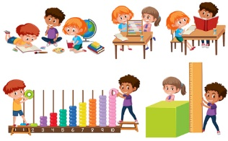  Number  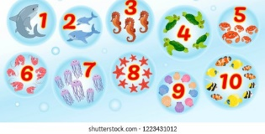  We follow the NCETM Mastering Number Programme for Reception  Numerical Patterns | Numbers 1-5  Time – register time; phonics time; choosing time; tidy up time; lunchtime; carpet time; story time; hometime. Yesterday, today and tomorrow.  Shape- circle  Count objects, actions, and sounds 1:1 correspondance to 10 or beyond.  Subitise, count, order  to 5  Matching. Sorting & Comparing/Pairs  Comparing amounts – more/fewer/ same  Comparing size – tall/short; big, small; mass & capacity.  Exploring pattern - making simple repeat patterns 1 2 1 2 1 2 1 2  Stem sentences: 2 is made of 1 and 1, 1 and 1 is 2.  3 is made of 2 and 1 etc  Vocabulary: less than, more than, equal to  What is different?  What is the same?  Circle, square, triangle | Numbers 5, 0  Time  Positional language  Shape- circles, triangles, squares  Early doubling  Verbally count beyond 20  1 more and 1 less  Explore the composition of numbers to 5  Subitise  Automatic recall number bonds 0-10  Representing, comparing, composition formation of 1,2,3,4 and 5 |  | Numbers 5, 6, 7  Time  Shape  Early doubling  Comparing mass and capacity  Explore the composition of numbers to 10  Subitise  Automatic recall number bonds 0-10  Introducing zero  Comparing and composition to 5  Comparing 2 groups  Length, height and time | Numbers 8, 9, 10  Subitise up to 5  Halving  Doubling  Sharing  Compare quantities up to 10 in different contexts, recognising when one is greater than, less than or the same as the other  Explore the composition of numbers to 10  Subitise  Automatic recall number bonds 0-10  Numbers 7, 8, 9  Making pairs.  Combining groups  Number bonds  3D shapes  Pattern. | Money, time, shape  Halving, doubling, sharing  Deep understanding of number to 10, including composition.  Recognise the pattern of number system  Explore the composition of numbers beyond 10.  Subitise  Automatic recall number bonds 0-10  Number 10 and beyond– subitising, counting, sorting, matching, comparing, ordering  Composition of numbers to 10 and beyond  Counting patterns to 10 and beyond  Spatial reasoning.  3D shape  Match, rotate, and manipulate  Pattern – AABB, BBA |  |  | Money, time, shape  Halving, doubling, sharing, Grouping  Recall number bonds to 5 and some to 10  Explore and represent patterns within numbers up to 10, including evens and odds, double facts and how quantities can be distributed equally,  Explore the composition of numbers beyond 10.  Subitise  Adding more –  Taking away  Exposure to recording pictorially and nEumber sentences  Automatic recall number bonds 0-10  Shape, spatial reasoning
Link the number symbol with its cardinal number value. Select, rotate, and manipulate shapes to develop spatial reasoning skills.
Count beyond ten. Compare numbers Compose and decompose shapes so that children recognise a shape can have other shapes within it, just as numbers can.
Understand the ‘one more/one less than’ relationship between consecutive numbers. Continue, copy, and create repeating patterns.
Compare length, weight, and capacity.
Understanding the World  Past and Present  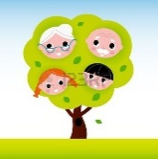  People, Culture and Communities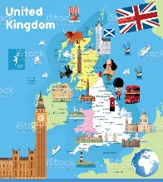  The Natural World (ART)  Explore the natural world around them, making observations and drawing pictures of animals and plants  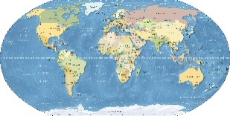 | Chronology: Talk about members of their immediate family and the relationship to them. and community  Name and describe people who are familiar to them.  Describe immediate environment using knowledge from discussion, observations, stories, non-fiction and maps.  Explore the natural world around us, making observations and drawing pictures of animals and plants  Respect:  Themselves, special things in their own lives.  Talk about and describe features of their own family, talk about families in other countries across the world.  Mapping: Talk about the features of their immediate environment with visual representations e.g., classroom maps  Look at the World Map and work out where we live in England and where the South Pole is (Lost and Found story) – mark a route. Compare climates.  Look at World Map and identify where France is compared to England. Is it nearer or further than the South Pole? Compare climates with England and South Pole.  Globetrotting to France!   | Chronology: use the language of time when talking about past/present events in their own lives and in the lives of others including people they have learnt about through books.  Enquiry: Find out about key historical events and why and how we celebrate today? Remembrance Day, Christmas Day, Diwali. Ask questions, use different sources to find answers including books.  Respect:  Recognise that people have different beliefs and celebrate special times in different ways.  Recognise some similarities and differences between life in this country and life in other countries.  Look closely at and make comparisons between this country and the lives of people in other countries within the world (homes around the world)  Comment on images of familiar situations in the past.  Mapping: Use technology e.g., a BeeBot and begin to show spatial awareness. Use positional language i.e., under, beside, on top of etc.  Know some similarities and differences between: things in the past and now; life in this country and life in other countries; different religious and cultural communities in this country  Recognise that people have different beliefs and celebrate special times in different ways. |  | Chronology: Visually represent their own day on a simple timeline (correspond with number 7 work, days of the week. Recognise some environments that are different to the one in which they live, between the natural word and contrasting environments.  Understand the past through settings, characters and events encountered in books and read in class.  Explain some similarities and differences between life in this country and others., drawing on knowledge.  Respect:  Understand the value of being curious and interested in finding out about people within their own community and in other countries - special places and events or objects – through non-fiction texts, stories, visitors, celebrations.  Mapping: Program a BeeBot or instruct a friend to move along a track or small world setup in a specific direction using terms up, down, side.  Identify on a map - Recognise some environments that are different to the one in which they live e.g., extreme hot and cold climates  Enquiry: Use technology and IT equipment to make observations or find information about different locations and places. Recognise, know, and describe features of different places. Look closely at similarities and differences. | Understand that some places are special to members of their community.  Chronology: Talk about and understand changes in their own lifetime, by creating a personal timeline.  Enquiry: Describe images of familiar situations in the past using books such as, ‘When we were giants’, ‘Peepo’, Shirley Hughes stories.  Respect:  Understand the value of being curious and interested in finding out about people within their own community and in other countries - special places and events or objects – through non-fiction texts, stories, visitors, celebrations  Mapping: Complete a simple BeeBot program using a grid map or carpet squares.  Lifecycle of a chick/frog- Living Eggs hatching and frogspawn  Enquiry - comment and ask questions about their immediate environment, other places which are familiar to them, and places they have learnt about e.g., school nature area and the town centre | Chronology: Recount an event, orally, pictorial – The Queen  Enquiry: Talk about key roles people have in society both in the present and past. Name and describe people who are familiar to them within their community e.g., police, fire service, doctors, dentist.  Respect:  Understand that some places are special to members of their community.  explore the natural world around them.  Draw information from a simple map.  Understand some important processes and changes in the natural world around them, including the seasons and changing states of matter. Lifecycles. Planting grassheads.  Mapping: Draw information from a simple map and identify landmarks in London and compare to our local area  Enquiry: Comment and ask questions about the different parts of the local community. E.g., weather, house, ca, canal, allotment, garden, field, forest, shop. Use photos and pictures to locate places and place on a simple map.  Find out about their local area by talking to people, examining photographs, and recalling experiences  Understand the key features of the life cycle of a plant or animal |  |  | Chronology: Order experiences in relation to themselves and others, including stories.  Enquiry:  Comment on images of familiar situations in the past. Describe features of objects, people, places at different times and make comparisons. Talk about what is the same and different. Comment on images of familiar situations in the past.  Compare and contrast characters from stories, including figures from the past.  Respect:  Animals and know how to care for an animal/pets/plants  Mapping: Create own maps using grid paper and symbols  Planting sunflowers.  Enquiry: Recognise, know, and describe features of different places. Look closely at similarities and differences between their immediate environment and different places they have visited, learnt about through books or websites
Communication: Comment on what they notice about the environment where they live and understand the effect of the changing seasons on the natural world around them. Describe what they see, hear, and feel outside.
Observation: Explore the natural world around them by taking part in weekly forest school sessions and making observations and drawing pictures of animals and plants. Understand the need to respect and care for the natural environment and all living things.

Expressive Arts and Design  Creating With Materials (ART)  Safely use and explore a variety of materials, tools and techniques, experimenting with colour, design, texture, form and function  Share their creations, explaining the process they have used  Performing  Musical instruments  Dance  Singing  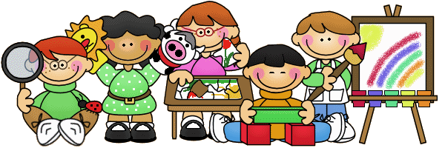 | Paintings of Monet 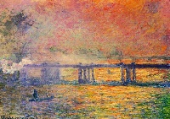  Portrait skills – drawing themselves- for our Art Gallery  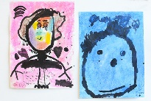  Creating with Materials  explaining the process they have used  Exploring colour and shape:  ART: Creating, Drawing, Exploring and Evaluating 3D Sculpture (Junk modelling)  Key vocabulary: explain, explore, same, different, like, dislike, change, compare, describe, record, resources, skills, cut, rip, tear, stick, print, thick, thin, build, roll | Pen and chalk/printing/powder paint  Artist – Jackson Pollock  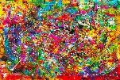  ART: straight, curved, explain, explore, famous, shape, join , rough, smooth,  Painting Feature Artist: Wassily Kandinsky  Safely use and explore a variety of materials, tools and techniques, experimenting with colour, design, texture, form and function.  Key vocabulary: thick, thin, pencil, straight, curved |  | Collage/painting –shading  Artist – Kandinsky  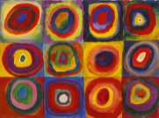  Return to and build on their previous learning, refining ideas and developing their ability to represent them.  ART: same, different, like, dislike, change, compare, Collage,  Return to and build on their previous learning, refining ideas and developing their ability to represent them  Painting:  safely use and explore a variety of materials, tools and techniques, experimenting with colour, design, texture, form and function  share their creations, explaining the process they have used | ART: artist, artwork, gallery ,  Feature Artist: Mark Rothko,  texture 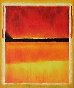  Create sharing ideas, resources, and skills  Piet Mondrian  ,  Share their creations, create collaboratively sharing ideas, resources, and skills.  Key vocab:  primary colours (red, blue, yellow), green, orange, purple, black, white, pink, grey, brown, mix, paint brush, bristles, brush size | Natural transient art  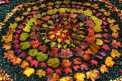  ART: Feature Artist: Andy Goldsworthy, scrunch, manipulate, sculptures Malleable  Listen attentively, move to and talk about music, expressing their feelings and responses.  Explain the resources/process they have used for their creations  Collage: Key vocab: cut, rip, tear, scrunch, stick |  |  | Using natural materials:  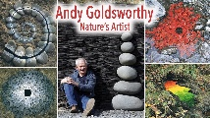  Andy Goldsworthy  ART: describe, record, resources, natural materials skills, 3D Sculpture (Junk modelling  Watch and talk about dance and performance art, expressing their feelings and responses  Printing: use a range of small tools, including scissors, paint brushes and  3D Sculpture:  Key vocab: sculptures, build, roll, shape, manipulate, join  Listen attentively, move to, and talk about music, expressing their feelings and responses.
Explore and engage in music making and dance, performing solo or in groups. Singing – well known nursery rhymes, familiar songs and chants.
Explore, use, and refine a variety of artistic effects to express their ideas and feelings Invent, adapt, recount narratives and stories with peers in play.
Explore and engage in music making and dance, performing solo or in groups, when appropriate in time with music. Make use of props and materials when role-playing characters in narratives and stories in play.

