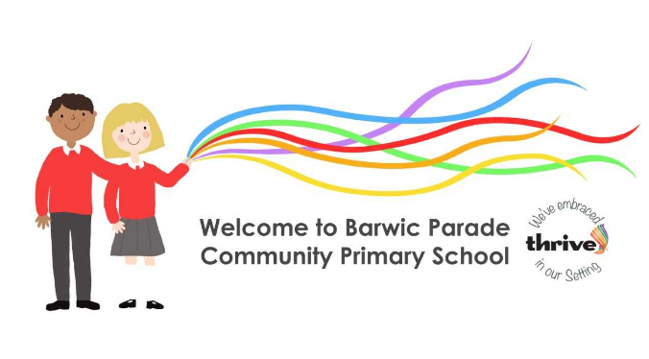

Relationships & Sex Education Policy 2025

Version Number | V009
Policy Writer | Sarah Dixon, Headteacher
Document Owner | Sarah Dixon, Headteacher
Issue Date | 4th March 2026
Date for Review | Spring 2027 or sooner if NYC policy changes

Details
Name | Barwic Parade Community Primary School
Type of school | Mainstream Primary School, including Breakfast Club, Governor Led Nursery and After School Club
Address  (including What3Words location) | Petre Avenue  Selby  YO8 8DJ  ///void.zones.engineers
Operating hours | 7.45am to 5.30pm
Office telephone number | 01757 705591
Office email address | admin@barwicparade.co.uk
Approximate number of staff | 22
Approximate number of pupils & age range | 200  2yrs to 11yrs

Version Control
Version | Date | Amended by | Summary of key changes
V001 | January 2012 |  | Policy created
V002 | January 2015 | Mrs Battersby | Policy updated & ratified
V003 | March 2018 | Miss Kirkland | Policy updated & ratified
V004 | October 2020 | Miss Kirkland | Policy updated & ratified
V005 | October 2021 | Miss Kirkland | Policy updated & ratified
V006 | October 2023 | Miss Kirkland | Policy updated & ratified
V007 | May 2025 | Miss Kirkland | Policy updated & ratified
V008 | March 2025 | Miss Kirkland | Policy updated & ratified
V009 | March 2026 | Miss Kirkland | Policy updated & ratified

Relationships & Sex Education (RSE)
Reference to legislation and schools responsibilities

This policy is informed by Relationships, Education, Relationships and Sex Education (RSE) and Health Education 2019, last updated December 2025 – for introduction September 2026.
https://assets.publishing.service.gov.uk/media/6970e7e67e827090d02d42e0/Relationships_education_relationships_and_sex_education__RSE__and_health_education__for_intro_1_September_2026_.pdf

Consultation
This Policy was developed in consultation with Teaching Staff and Governors at school.All stakeholders were asked to provide feedback to be written into the Policy. The Policy will be reviewed annually unless otherwise informed.

Parents/Carers are be able to access the Policy on the school Website and a hard copy will be made available upon request.

This policy links to:

Safeguarding/child protection. North Yorkshire Safeguarding Children Board Procedures and Guidance (www.safeguardingchildren.co.uk)

- Positive Behaviour and Relationships Policy
- PSCHE Curriculum
- SEND Policy
- Teaching and Learning
- Assessment
- Science
- Single Equality Scheme

The definition of Relationships and Sex Education (RSE)
The Relationships Education, RSE, and Health Education (England) Regulations 2019 have made Relationships Education compulsory in all primary schools. Sex education is not compulsory in primary schools and the content set out in this guidance therefore focuses on Relationships Education. Relationships education is learning about the emotional, social and physical aspects of growing up, relationships. It supports pupils to gain accurate information, develop skills and form positive beliefs, values and attitudes. It also gives pupils essential skills for building positive, enjoyable, respectful, loving and non-exploitative relationships and staying safe both on and offline and enabling them to take responsibility for their body, relationships, reproduction, sexual health and wellbeing. The Department for Education defines relationships education as, teaching the fundamental building blocks and characteristics of positive relationships,with particular reference to friendships, family relationships and relationships with other peers and adults.

Sex education is not compulsory in primary schools but the content in the Governments new guidance covers everything that primary schools should teach about relationships and health. Puberty education is statutory under health education; it is introduced to children at Barwic Parade during Lower Key Stage 2 and specifically in Year 4. Children are taught to understand how their bodies will change both physically and mentally and will develop skills to help them look after themselves emotionally and physically during this time. The national curriculum for science also includes subject content in related areas. The DfE do recommend that all primary schools should have a sex education programme tailored to the age and physical and emotional maturity of the pupils. Barwic Parade School chooses to teach some aspects of sex education and will continue to do so.

Sex education includes drawing on knowledge of the human life cycle set out in the national curriculum for science – the ways a baby could be conceived and born. Year 6 children will join in with lessons which focus on understanding human reproduction and birth; identifying the links between love, committed relationships and conception; identifying what sexual intercourse is and how it can be done as part of an intimate relationship between consenting adults; identifying how pregnancy occurs i.e. when a sperm meets an egg and the fertilised egg settles into the lining of the womb and knowing that pregnancy can be prevented with contraception. Barwic Parade use the Busy Bodies resource to teach these aspects of the curriculum https://www.socialworkerstoolbox.com/education-puberty-10-14yrs-old-busy-bodies-adolescent-development-programme/

The school’s statement of values and ethos

- High quality RSE helps to create safe school communities in which pupils can grow, learn, and develop positive, healthy behaviours for life, and learn about safeguarding both on and offline
- Children and young people want to be prepared for the physical and emotional changes they undergo at puberty, and young people want to learn about relationships. Older pupils frequently say that sex and relationships education was ‘too little, too late and too biological’. Ofsted reinforced this in their 2013 Not Yet Good Enough report.
- Technology is evolving at a tremendous pace. The need to protect children and young people from inappropriate online content, cyber-bullying and exploitation is a growing concern. A comprehensive RSE programme can support in addressing these issues.
- Research shows that a comprehensive RSE programme delays sexual activity for young people and increases the likelihood that they will use contraception. A link has been shown between effective school based RSE and reductions in teenage pregnancy (National Survey of Sexual Attitudes and Lifestyles 2013)
- A summary of the latest research evidence relating to relationships and sex education, particularly the contribution of RSE to behaviour change demonstrates the positive impact of High Quality RSE - https://www.sexeducationforum.org.uk/resources/evidence/relationships-and-sex-education-evidence

Children and young people are supported to:

- Develop an awareness, understanding and respect for self, including self-confidence and self-esteem
- Develop an awareness and respect for others and their view
- Take responsibility for choices and actions
- Understand and empathise with others enabling pupils to treat others with fairness and respect
- Develop an awareness of discrimination, teasing, bullying, the use of prejudiced-based language and how to respond and ask for help
- Develop relationships based on mutual understanding and trust
- Develop a regard for family life, friends and the wider community

What will be the aims, objectives and outcomes of RSE?

Attitudes and Values

- learning the importance of values, individual conscience and moral considerations
- learning the value of marriage, family life and stable relationships
- learning the value of respect, love, care and relationships (both on and offline) that are healthy, equal and safe
- exploring, considering and understanding moral dilemmas
- challenge stereotypes and gendered expectations (both on and offline for both boys and girls
- developing critical thinking as part of decision making

Personal and Social Skills

- learning to manage emotions and relationships confidentially and sensitively
- developing self-respect and empathy for others
- equipping pupils with the information, skills and values to have safe, fulfilling and enjoyable relationships (both on and offline
- learning to make choices based on an understanding of difference and with an absence of prejudice
- exploring and developing the social and personal skills needed to make informed choices with an appreciation of the consequences of the choices made
- developing assertiveness skills for managing negotiation and conflict
- learning how to recognise and avoid abuse, control and exploitation, and how to seek help if they are being abused/exploited
- learning how to recognise pressure and ways of dealing with it
- understanding a range of different families, sexualities and the gender spectrum; Lesbian, Gay, Bisexual and Transgender (LGBT) and are able to challenge homophobic, biphobic and transphobic language and bullying
- taking responsibility and having respect for their bodies, wellbeing and sexual health
- developing the knowledge and skills to be able to seek appropriate help

Knowledge and Understanding

- learning and understanding physical and emotional development at appropriate stages, including the appropriate terminology to describe the names for their genitalia and reproductive organs
- learning that their body belongs to them and they can say who has access to it
- learning and implementing strategies to keep themselves safe both on and offline
- considering the impact of the media on body image and portrayal of all genders
- understanding human sexuality, reproduction, sexual health, emotions and healthy relationships
- learning about contraception and protection and the importance of protecting against STI’s and the range of local and national sexual health advice, contraception and support services
- learning the reasons for delaying sexual activity, and the benefits to be gained from such a delay
- understanding how to avoid an unplanned pregnancy
- learning about the law and sexual consent

Statement of responsibilities of all stakeholders

The Governing Body
The Governing Body has the responsibility to ensure the school has an up-to-date RSE policy that describes the content and organisation of RSE through the national curriculum in science and other curriculum areas like PSHE. The governing body, in co-operation with the Headteacher, is expected to involve families, pupils, and the wider school community to ensure that RSE addresses the needs of pupils, local issues and trends. The governing body need to ensure pupils are protected from teaching and materials which are inappropriate, having regard to the age, religious and cultural background of the pupils. They will ensure that the policy is available to parents/carers and that they know of their right to withdraw their children. Governors will ensure that the programme and the resources are monitored and evaluated. This monitoring applies to both the taught curriculum and the wider areas of school life. The governing body and proprietors have the responsibility through the statutory guidance ‘Keeping Children Safe in Education’. “Governing bodies and proprietors should ensure that children are taught about how to keep themselves and others safe, including online. It should be recognised that effective education will be tailored to the specific needs and vulnerabilitiesof individual children, including children who are victims of abuse, and children with special
educational needs and/or disabilities.’ The governing body has the responsibility to ensure the school is meeting requirements under the equalities legislation (Equalities Act 2010), so they need to ensure the curriculum reflects the diversity of modern Britain including representing a range of families, sexualities and gender in both primary and secondary schools.

Schools and colleges play a crucial role in preventative education. Preventative education is most effective in the context of a whole school or college approach that prepares pupils and students for life in modern Britain and creates a culture of zero tolerance for sexism, misogyny/misandry, homophobia, biphobic and sexual violence/harassment. The school will have a clear set of values and standards, upheld and demonstrated throughout all aspects of school life. These will be underpinned by the school’s behaviour policy and pastoral support system, as well as by a planned programme of evidence based RSE delivered in regularly timetabled lessons and reinforced throughout the whole curriculum. The programme should be fully inclusive and developed to be age and stage of development appropriate (especially when considering the needs of children with SEND and other vulnerabilities). This program will tackle, at an age-appropriate stage, issues such as: • healthy and respectful relationships • boundaries and consent • stereotyping, prejudice and equality • body confidence and self-esteem

The Headteacher
The Headteacher has responsibility for the day-to-day management of all aspects of the school’s work, including teaching and learning. The Headteacher’s responsibilities in respect of RSE are to:

• Work with governors to ensure compliance with the statutory guidance
• Liaise with the PSHE co-ordinator to ensure the effectiveness of the delivery of the RSE within the curriculum is being monitored
• Keep the governing body fully informed of provision, issues and progress around RSE issues
• Act upon any concerns which may arise from a pupil’s disclosure during RSE sessions
• Monitor staff training requirements in relation to effective teaching and learning of RSE
• Ensure parents/carers are informed when their children will be taught RSE to support a partnership approach but also that they do have the right to withdraw their child from any RSE that is not part of the National Curriculum Science programme

The PSHE Co-ordinator
The school co-ordinator for PSHE, Becky Kirkland is responsible for all aspects of the subject including RSE. In respect to RSE, responsibilities are to:

• Ensure the implementation and quality of long term and medium term RSE schemes of work
• Ensure that all staff are confident in the skills to teach and discuss RSE issues as trained, confident and competent staff are essential to raise standards in RSE
• Consider the needs of all pupils, and to achieve this recognise that the school might need to address some specific issue.
• Consult with pupils to inform provision around RSE and use the schools’ Growing Up in North Yorkshire bi-annual survey results to inform planning
• Access appropriate training
• Monitor and advise on RSE organisation, planning and resource issues across the school
• Ensure procedures for assessment, monitoring and evaluation are included
• Liaise with the governors as appropriate
• Liaise with any service provision to support aspects of sexual health
• Co-ordinate with external providers to ensure their provision meets the outcomes of the planned provision using age appropriate materials
• Liaise with the Headteacher to ensure parents/carers are informed when their children will be taught RSE to support a partnership approach and to also inform them that they do have the right to withdraw their child from any RSE that is not part of the National Curriculum Science programme

Parents / Carers
School aims to work in active partnership with families, value their views and keep them informed of the RSE provision. If a parent/carer has any concerns about the RSE provision then time should be taken to address their concerns. Families can be invited to review the resources and can contact the Headteacher with any queries or concerns. Families can be signposted to relevant support from colleagues within school.

The Parental Right to withdraw their child from RSE lessons
Under section 405 of the Education Act 1996, parents may opt to withdraw their children from lessons which address sex education. Parents should be notified in writing of the programme and the content for RSE and reminded of their right to withdraw their children. Parents wanting to exercise this right are invited to see the PSHE Co-ordinator who will explore their concerns. From September 2026, If a child is withdrawn, the school will record this on to the CPOMs system. They will be provided with alternative work for the duration of the lessons and consideration will be given on how to protect a pupil from the possible reaction of their peers to this withdrawal. Children will be aware that this withdrawal is option and they will receive guidance on how to respond to other children following the session. Should the reaction of peers become more severe it will be dealt with on a case by case basis depending on the nature and severity of the reaction Parents and carers can view any curriculum materials that are used to teach the statutory RSHE guidance. Parents will be informed by letter before the teaching of the letter and will be invited to discuss further or to look at the content by arranging to meet with Becky Kirkland PSCHE co-ordinator.

External agencies
Whilst the responsibility for organising and delivering most, if not all, of the RSE programme rests with the school, there may be times when an external contributor can add value and bring additional experience, skills or knowledge that teachers may not always have. However they may not possess the skills of organising teaching and learning or managing behaviour. It is essential to ensure that at all times a member of staff is present when an external contributor is working with pupils. The visitors’ input will be more effective if a teacher provides the context and follow up to the session. All external visitors should have Disclosure and Barring Service check (DBS).

Delivery of RSE and the curriculum
The RSE programme is firmly embedded within the school’s framework for PSHE and the National Curriculum for Science. The RSE curriculum is delivered through Science, PSHE lessons.

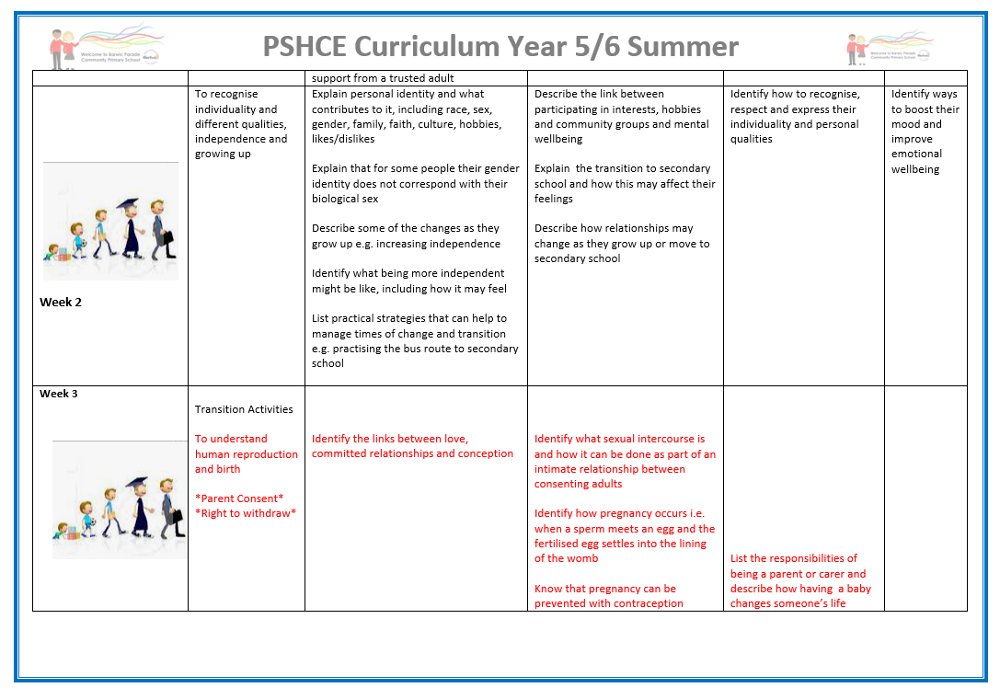

Extract of the school’s PSCHE Curriculum – can be accessed via the school website.

School’s RSE programme is taught from Early Years and continues progressively year on year. Children will learn about different types of relationships and consent and will learn to name body parts in the earlier years building up to Puberty Education and Sex Education which is delivered using the the Busy Bodies Scheme. This supports specific delivery of the curriuclum in Year 6 and generates a readiness for secondary school. Year 6 teachers access Local Authority training biannually to ensure they remain up-to-date with specific requirements. Provision is planned effectively by individual Class Teachers to ensure all learners within all classes (including SEND, ethnicity, faith, sexual orientation and gender) are catered for.

Procedures for assessment, monitoring, evaluating and reviewing

RSE will be assessed in accordance with the school’s policy for Assessment, Monitoring, Evaluating and Reviewing of Curriculum Subjects.

Assessment of the curriculum:
• Provides regular opportunities for pupils to give and receive feedback on their progress and achievements, helping them to identify what they should do next
• Involves pupils in discussion about learning objectives and desired outcomes
• Includes pupils as partners in the assessment process e.g. through self-assessment and peer-assessment
• Enables pupils to identify and gather evidence of their progress in developing knowledge, skills, understanding and attitudes
• Reflects the principles of inclusion and the range of pupils learning styles enabling all pupils to demonstrate their achievement

School hold an internal assessment tracker (O-track) which is completed by Class Teachers at the end of the academic year to indicate each pupil’s level of understanding.

The school’s PSCHE lead will be responsible for monitoring the provision of RSE and for reporting the outcomes to the Senior Leadership Team, and via the Headteacher to the governing body. The PSHE co-ordinator is responsible for evaluating the programme of work, reporting the findings on an annual basis, and for making recommendations for changes to the programme.

The school bi-annually completes the Growing up In North Yorkshire Survey to support the monitoring and evaluation of the RSE provision and to identify any emerging issues for pupils.

Monitoring and Evaluation:
The RSE programme is reviewed and evaluated each year within the school’s framework for teaching and learning and delivery of the curriculum. The views of pupils, parents/carers and teachers are used to make changes and improvements to the programme on an ongoing basis.
School will:

- Review and plan the content and delivery of the programme of study for RSE
- Review resources and renew as appropriate
- Update training in line with current guidance and staff identified needs.
- Ensure the most up-to-date documentation from NYCC is used and considered when evaluating the programme (see appendix)

Confidentiality and Safeguarding issues are addressed
Safeguarding and confidentiality within RSE can be a sensitive issue. To protect privacy and engender respect for all, staff will be expected to develop ground rules with pupils at the onset of work. This will include information on confidentiality. Information will be given on where pupils can get help with personal concerns both inside and outside school. Pupils should be informed about the remit of confidentiality and that staff cannot offer or guarantee pupils unconditional confidentiality. Distancing techniques will be used throughout lessons and all staff will allow pupils the opportunity to ask further questions anonymously. If pupils ask particularly sensitive questions that appear to be inappropriate in the circumstances, staff will deal with this outside of the lesson but an agreed holding statement will be used for example, ‘that is a really interesting question and I need time to think because I want to give you a really good answer’ this then allows staff to follow a number of options. These include: further questioning of the pupil with another member of staff present asking them for interpretation of the question they asked. Time to consult with colleagues to construct an appropriate answer, or liaise with the pupil’s family, and obtain information about where to get further help or, if the matter is considered a potential Safeguarding issue, the school’s senior member of staff, with designated responsibility for Child Protection (DSL) will be notified. It is the responsibility of the school to support its pupils and to carry out its functions with a view to safeguarding and promoting the welfare of pupils. In fulfilling this duty they must have regard to guidance around safeguarding. Whilst pupils have the same rights to confidentiality as adults no pupil should be guaranteed absolute confidentiality. Staff will report any information or disclosure which raises concern that a child or children may be at risk of significant harm to the school’s senior member of staff, with designated responsibility for Child Protection. The Designated person will then, in line with the School’s Child Protection policy and the North Yorkshire Safeguarding Children Board guidance and procedures, take action as appropriate. Pupils will be made aware of the law relating to sexual offences and of those circumstances where confidentiality cannot be maintained.

Supporting children with Special Educational Needs and Relationships and Sex Education
Our school is committed to ensuring that Relationships and Sex Education (RSE) is inclusive, accessible and appropriate for all pupils, including those with Special Educational Needs and Disabilities (SEND).
We recognise that pupils with SEND may require additional support, adapted resources, or differentiated teaching approaches to fully access RSE learning. Staff will plan lessons that take account of pupils’ individual needs, abilities and levels of understanding.
To support pupils with SEND, the school will:
- Work closely with the SENDCo, pastoral staff and teaching assistants to ensure RSE lessons are accessible.
- Adapt teaching strategies, language and resources to meet pupils’ cognitive, communication and emotional needs.
- Use a range of approaches such as visual aids, small group work and scaffolded learning where appropriate.
- Provide opportunities for pupils to ask questions in a safe and supportive environment.
- Ensure that learning about relationships, personal boundaries, consent, and safety is taught clearly and in ways that pupils can understand and apply to real-life situations where possible.
- Be mindful that some pupils with SEND may be more vulnerable to exploitation or misunderstanding of social cues, and therefore ensure these topics are taught sensitively and explicitly.
Where necessary, RSE content may be carefully adapted while still meeting statutory requirements and ensuring pupils receive the essential knowledge they need to stay safe and build healthy relationships.
Parents and carers will be kept informed and involved where appropriate, and the school will work collaboratively with families and external professionals to support pupils’ learning and wellbeing.

Lesbian, Gay, Bisexual and Trans (LGBT) and work on Different Families
The 2010 Equalities Act sets out that schools are required to eliminate discrimination, advance equality and foster good relations, so the curriculum should cater for LGB, Trans and heterosexual pupils. This also means school has to be proactive in preventing and tackling homophobic, biphobic and transphobic bullying and make all children and young people feel included.

All families are different so it is important to avoid using language which focuses on the conventional mum and dad family structure and instead talks about families more broadly. LGB pupils (who make up approximately 6% of any school population) often report that their RSE is solely about heterosexual relationships, or that non heterosexual identities were addressed negatively. Pupils should be provided with the opportunities to learn about different family structures. Supporting resources have been developed to enable primary schools to introduce the topic of ‘different families – same love’.

For Year 6 pupils, in particular, who receive tailor made RSE sessions in relation to partners and sexual health issues there needs to be learning and resources that relate to LGB relationships integrated into the curriculum. It is also important when teaching RSE at all age groups to refer to the spectrum of gender identify for example include trans and gender neutral identities as well as challenging gender stereotypes.

